6A Mid-Points of Line Segments

- Find the midpoint of this pair of points:
- $\left(2,3\right) and (6,9)$

- $\left(2a,-4b\right) and (7a,8b)$

- AB is a diameter of a circle, where A and B are the coordinates (-3,8) and (5,4) respectively. Find the coordinates of the centre of the circle.

- PQ is a diameter of a circle, centre (2,-2). Given that P is (8,-5), find the coordinates of Q.

6B Perpendicular Bisectors of Line Segments

- The line AB is the diameter of the circle with centre C, where A and B are (-1, 4) and (5, 2) respectively. The line l passes through C and is perpendicular to AB. Find the equation of l.

- The line PQ is the Chord of the circle, centre (-3,5), where P and Q are (5,4) and (1,12) respectively. The line l is perpendicular to PQ and bisects it. Show that it passes through the centre of the circle.

- The lines AB and CD are chords of a circle. The line y = 3x – 11 is the perpendicular bisector of AB. The line y = -x – 1 is the perpendicular bisector of CD. Find the coordinates of the circle’s centre.

6C Equations of Circles
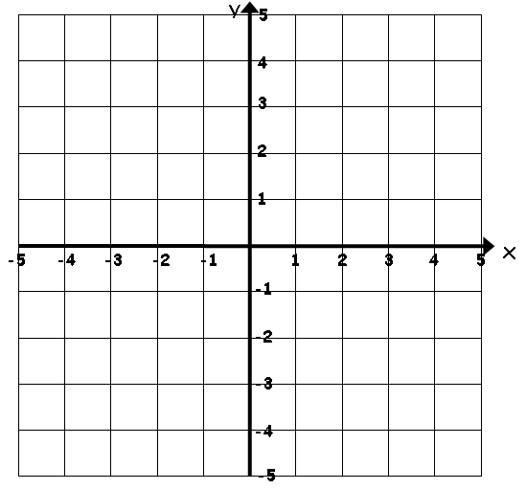

- Write down the equation of the circle with centre (5,7) and radius 4

- Find the coordinates of the centre, and the radius of, the circle with the following equation:
$${\left(x+3\right)}^{2}+{\left(y-1\right)}^{2}=4^{2}$$

- Find the coordinates of the centre, and the radius of, the circle with the following equation:
$${\left(x-\frac{5}{2}\right)}^{2}+{\left(y+4\right)}^{2}=32$$

- Show that the circle:
$${\left(x-3\right)}^{2}+{\left(y+4\right)}^{2}=20$$
Passes through (5,-8)

- The line AB is the diameter of a circle, where A and B are (4,7) and (-8,3) respectively. Find the equation of the circle.

- Find the centre and radius of the circle with equation:
$$x^{2}+y^{2}-14x+16y-12=0$$

6D Lines Intersecting Circles
- Find the coordinates where the line y = x + 5 meets the circle x² + (y – 2)² = 29.

- Show that the line y = x – 7 does not touch the circle (x + 2)² + y² = 33.

6E Applying Circle Theorems

- The line 4x – 3y – 40 = 0 is a tangent to the circle (x – 2)² + (y – 6)² = 100 at P = (10,0). Show that the radius at P is perpendicular to this line.

- A circle C has equation:
$${\left(x-5\right)}^{2}+{\left(y+3\right)}^{2}=10$$
The line $l$ is a tangent to the circle and has gradient -3. Find the two possible equations for $l$, giving your answers in the form $y=mx+c$.

6E Applying Circle Theorems

- The points A(-8,1), B(4,5) and C(-4,9) lie on the circle, as shown in the diagram.
- Show that AB is a diameter of the circle.

- Find an equation of the circle

- The points P(3,16), Q(11,12) and R(-7,6) lie on the circumference of a circle. The equation of the perpendicular bisector of PQ is $y=2x$.
- Find the equation of the perpendicular bisector of PR

- Find the coordinates of the centre of the circle

- Work out the equation of the circle

