5H Questions in Context
- The graph shows the extension, $E$, of a spring where different masses, $m$, are attached to the end of the spring.
- Calculate the gradient, $k$, of the line
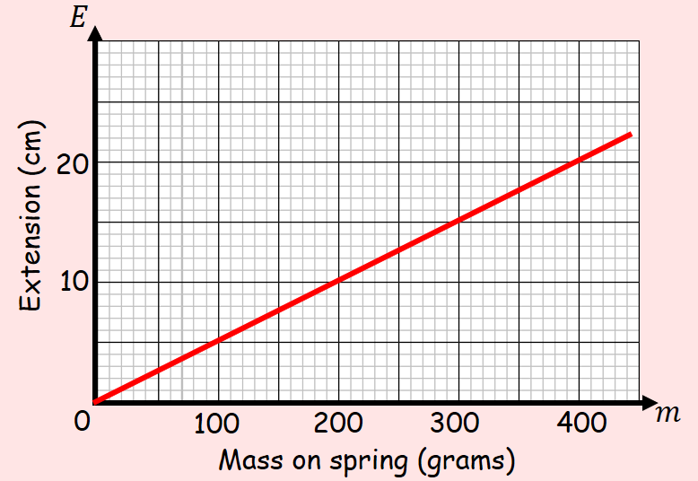

- Write an equation linking $E$ and $m$

- Explain what the value of $k$ represents in this context

- A container was filled with water. A hole was then made at the bottom of the container. The depth of the water was recorded at various time intervals, and the table shows the results.
Time, $t$ seconds | 0 | 10 | 30 | 60 | 100 | 120
Depth, $d$ cm | 19.1 | 17.8 | 15.2 | 11.3 | 6.1 | 3.5

- Determine whether a linear model is appropriate, by drawing a graph
$$t$$
$$d$$

- Deduce an equation in the form $d=at+b$

- Interpret the meaning of the coefficients a and b

- Use the model to estimate when the container will be empty

- In 1991 there were 18,500 people living in Bradley Stoke. Planners project that the number of people living in Bradley Stoke would increase by 350 each year.
- Write down a linear model for the population p of Bradley Stoke t years after 1991

- Write down one reason why this may not be a realistic model

