5A Finding Gradients

- Calculate the gradient of the line which passes through (-2,7) and (4,5)

- The line joining (2, -5) to (4, a) has a gradient of -1. Calculate the value of a.

5B y=mx+c

- Write down the gradient and y-intercept of the following graphs
- $y=-3x+2$

- $4x-2y+5=0$

- Write each equation in the form ax + by + c = 0
- $y=4x+3$

- $y=-\frac{1}{2}x+5$

- The line y = 4x + 8 crosses the x-axis at P. Work out the coordinates of P.

5C y-y₁=m(x-x₁)

- Find the equation of the line with gradient 5 that passes through the point (3,2)

- Find the equation of the line which passes through (5,7) and (3,-1)

- Find the equation of the line which passes through (5,7) and (3,-1)

5D Intersections

- The line y = 3x – 9 crosses the x-axis at coordinate A. Find the equation of the line with gradient ²/₃ that passes through A. Give your answer in the form ax + by + c = 0 where a, b and c are integers.

- The lines y = 4x – 7 and 2x + 3y – 21 = 0 intersect at point A. Point B has co-ordinates (-2, 8). Find the equation of the line that passes through A and B

5E Parallel Lines

- A line is parallel to the line $6x+3y-2=0$ and passes through the coordinate $(3,5)$. Find the equation of the line.

5F Perpendicular Lines

- Are the following lines perpendicular?
$$3x-y-2=0$$
$$x+3y-6=0$$

- Are the following lines perpendicular?
$$y=\frac{1}{2}x$$
$$2x-y+4=0$$

- A line is perpendicular to the line $2y-x-8=0,$ and passes through the coordinate (5,-7). Find the equation of the line.

5G Length of Line Segments

- Find the distance between the coordinates (2,3) and (5,7)

- The straight line $l_{1}$ with equation $4x-y=0$ and the straight line $l_{2}$ $2x+3y-21=0$ intersect at point A.
- Work out the coordinates of A.

- Work out the area of triangle AOB, where O is the origin and B is the point where $l_{2}$ meets the x-axis.

5H Questions in Context
- The graph shows the extension, $E$, of a spring where different masses, $m$, are attached to the end of the spring.
- Calculate the gradient, $k$, of the line
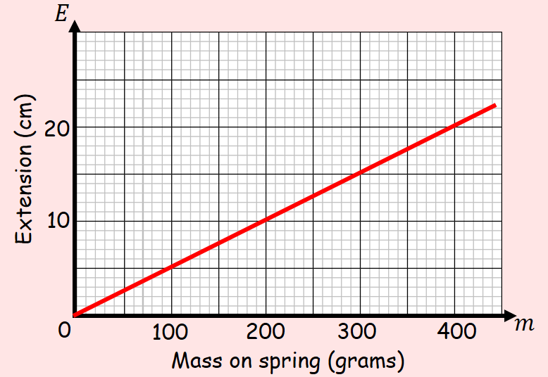

- Write an equation linking $E$ and $m$

- Explain what the value of $k$ represents in this context

- A container was filled with water. A hole was then made at the bottom of the container. The depth of the water was recorded at various time intervals, and the table shows the results.
Time, $t$ seconds | 0 | 10 | 30 | 60 | 100 | 120
Depth, $d$ cm | 19.1 | 17.8 | 15.2 | 11.3 | 6.1 | 3.5

- Determine whether a linear model is appropriate, by drawing a graph
$$t$$
$$d$$

- Deduce an equation in the form $d=at+b$

- Interpret the meaning of the coefficients a and b

- Use the model to estimate when the container will be empty

- In 1991 there were 18,500 people living in Bradley Stoke. Planners project that the number of people living in Bradley Stoke would increase by 350 each year.
- Write down a linear model for the population p of Bradley Stoke t years after 1991

- Write down one reason why this may not be a realistic model

