4A Sketching Cubic Graphs

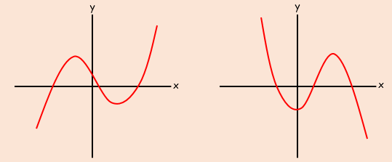

- Sketch the graph of the function:
$y=\left(x-2\right)\left(x-1\right)(x+1)$

x
y

- Sketch the graph of the function:
$y=\left(x-2\right)\left(1-x\right)(x+1)$

x
y

- Sketch the graph of the function:
$y={\left(x-1\right)}^{2}(x+1)$

x
y

- Sketch the graph of the function:
$$y=\left(x-1\right)\left(x^{2}+x+2\right)$$

x
y

