4A Sketching Cubic Graphs

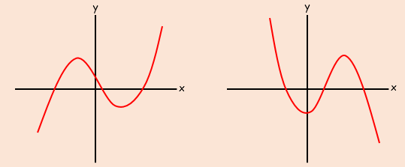

- Sketch the graph of the function:
$y=\left(x-2\right)\left(x-1\right)(x+1)$

x
y

- Sketch the graph of the function:
$y=\left(x-2\right)\left(1-x\right)(x+1)$

x
y

- Sketch the graph of the function:
$y={\left(x-1\right)}^{2}(x+1)$

x
y

- Sketch the graph of the function:
$$y=\left(x-1\right)\left(x^{2}+x+2\right)$$

x
y

4B Sketching Quartic Graphs

- Sketch the curve:
$$y=\left(x+1\right)\left(x+2\right)\left(x-1\right)\left(x-2\right)$$

x
y

- Sketch the curve:
$$y=x{\left(x+2\right)}^{2}(3-x)$$
x
y

- Sketch the curve:
$$y={\left(x-1\right)}^{2}{\left(x-3\right)}^{2}$$

x
y

4C Sketching Reciprocal Graphs

- Sketch the graph:
$$y=\frac{3}{x}$$

x
y

- Sketch the graph:
$$y=-\frac{1}{x}$$
x
y

- Sketch the graph:
$$y=\frac{1}{x^{2}}$$

x
y

4D Intersecting Graphs

- On the same diagram, sketch the following curves:

$y=x\left(x-3\right)$ and $y=x^{2}\left(1-x\right)$
x
y

- Find the co-ordinates of the points of intersection

- On the same diagram, sketch the following curves:

$y=\frac{3}{x}$ and $y=x^{2}\left(x-1\right)$
x
y

- Explain how the graph shows that the following equation has 2 solutions

4E Translating Graphs

- Sketch the following graphs:
- $y=x^{2}$
- $y={\left(x-2\right)}^{2}$
- $y=x^{2}+2$
x
y

- Given that $f\left(x\right)=x^{3}$ and $g\left(x\right)=x\left(x-2\right)$,
sketch the graphs of $y=f\left(x+1\right)$ and $y=g(x+1)$
x
y
x
y

- Given that $h\left(x\right)=\frac{1}{x}$, sketch the curve with equation $y=h\left(x\right)+1$, stating the equations of any asymptotes and intersections with the axes
x
y

4F Stretching Graphs

- Given that $f\left(x\right)=9-x^{2}$, sketch the curves with equations:
- $y=f(2x)$
- $y=2f(x)$
x
y

x
y
x
y

- Sketch the curve with equation $y=x(x-2)(x+1)$
x
y

- Hence, sketch the curve $y=2x(2x-2)(2x+1)$
x
y

- Based on your sketch in a), also sketch the curve $y=-x(x-2)(x+1)$
x
y

- On the same set of axes, draw the graphs of $y=f(x)$, $y=f(-x)$ and
$y=-f(x)$ where $f\left(x\right)=x(x+2)$
x
y

4G Unfamiliar Functions
- The diagram to the right shows a sketch of the curve $f(x)$ which passes through the origin. The points $A(1,4)$ and $B(3,1)$ also lie on the curve.
y
x
(1,4)
(3,1)
$$f(x)$$

- Sketch the graph of $y=f(x+1)$
y
x

- Sketch the graph of $y=f(x-1)$
y
x

- Sketch the graph of $y=f\left(x\right)-4$
y
x

- Sketch the graph of $2y=f(x)$
y
x

