3F Interpreting Graphical Non-Linear Inequalities

- $L_{1}$ has equation $y=12+4x$
$L_{2}$ has equation $y=x^{2}$
The diagram below shows a sketch of $L_{1}$ and $L_{2}$ on the same axes.

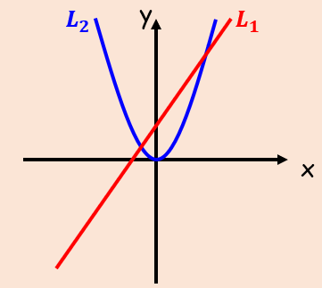

- Find the coordinates of the points of intersection

- Hence write down the solution to the inequality $12+4x>x^{2}$

