3C Simultaneous Equations Graphically (With the Discriminant)

- Draw the graphs of the following equations and use it to write down their solution:
$2x+3y=10$
$$x$$
$$y$$
$$3x-y=4$$

- Draw the graphs of the following equations and use it to write down their solution:
$2x+y=3$
$$x$$
$$y$$
$$y=x^{2}-3x+1$$

Notes on the discriminant:
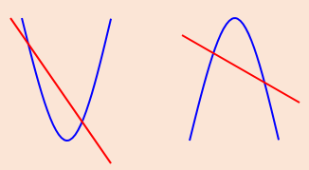
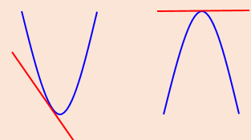
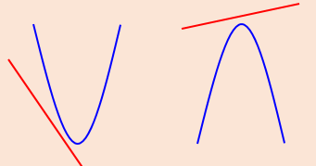
- The line with equation $y=2x+1$ meets the curve with equation
$$kx^{2}+2y+\left(k-2\right)=0$$
at exactly one point. Given that $k$ is a positive constant:
- Find the value of $k$

- For this value of $k$, find the coordinates of the point of intersection

