3A Linear Simultaneous Equations

- Solve the following Simultaneous Equations by Elimination
$2x+3y=8$
$$3x-y=23$$

- Solve the following Simultaneous Equations by Substitution
$2x-y=1$
$$4x+2y=-30$$

3B Non-Linear Simultaneous Equations

- Solve the following Simultaneous Equations
$$x+2y=3$$
$$x^{2}+3xy=10$$

3C Simultaneous Equations Graphically (With the Discriminant)

- Draw the graphs of the following equations and use it to write down their solution:
$2x+3y=10$
$$x$$
$$y$$
$$3x-y=4$$

- Draw the graphs of the following equations and use it to write down their solution:
$2x+y=3$
$$x$$
$$y$$
$$y=x^{2}-3x+1$$

Notes on the discriminant:
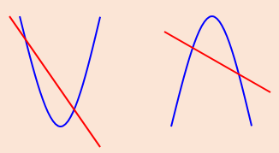
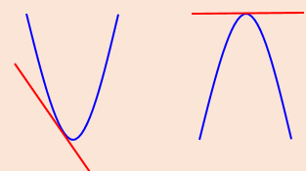
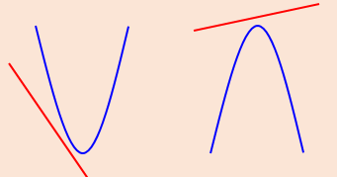
- The line with equation $y=2x+1$ meets the curve with equation
$$kx^{2}+2y+\left(k-2\right)=0$$
at exactly one point. Given that $k$ is a positive constant:
- Find the value of $k$

- For this value of $k$, find the coordinates of the point of intersection

3D Linear Inequalities

- Find the set of values of x for which:
- $2x-5<7$

- $5x+9≥x+20$

- $12-3x<27$

- $3\left(x-5\right)>5-2(x-8)$

- Find the set of values of x for which:
- $3x-5<x+8$ and $5x>x-8$

- $x-5>1-x$ and $15-3x>5+2x$

- $4x+7>3$ and $17<11+2x$

3E Quadratic Inequalities

- $x^{2}-4x-5<0$

- $3-5x-2x^{2}<0$

- Find the values of k for which the equation:
$$\left(k+3\right)x^{2}+6x+k-5=0$$
has two real roots.

- Find the set of values for which:
$$\frac{6}{x}>2$$

3F Interpreting Graphical Non-Linear Inequalities

- $L_{1}$ has equation $y=12+4x$
$L_{2}$ has equation $y=x^{2}$
The diagram below shows a sketch of $L_{1}$ and $L_{2}$ on the same axes.

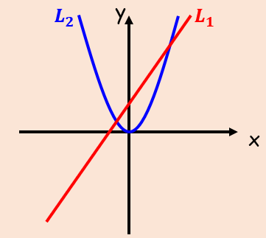

- Find the coordinates of the points of intersection

- Hence write down the solution to the inequality $12+4x>x^{2}$

3G Shading Inequality Regions

- On graph paper, show the region that satisfies the following inequalities:
$$y≥-2$$
$$x<5$$
$$y≤3x+2$$
$$x>0$$
$$x$$
$$y$$

- On graph paper, show the region that satisfies the following inequalities:
$$x$$
$$y$$
$$2y+x<14$$
$$y>x^{2}-3x-4$$

