2G The Discriminant
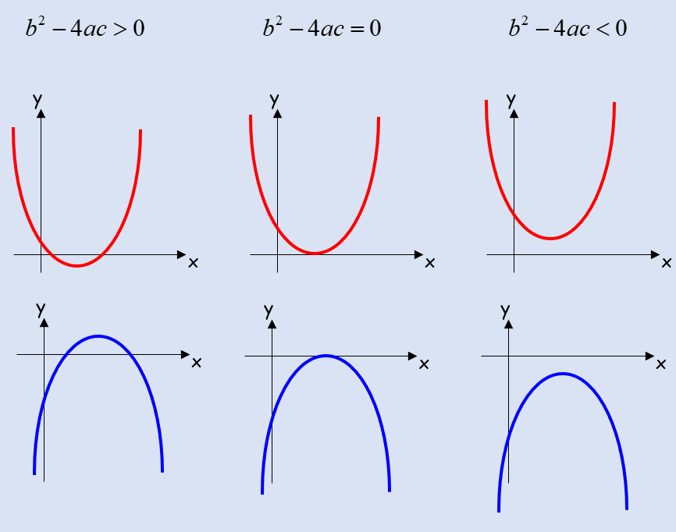

- Find the values of k for which;
x² + kx + 9 = 0
has equal roots.

- Find the values of k for which;
x² + 4x + k = 0
has two distinct real solutions.

