2A/B Solving Quadratic Equations

- Solve the Equation
- $x^{2}=9x$

- $x^{2}-2x-15=0$

- $2x^{2}-9x-5=0$

- $6x^{2}+13x-5=0$

- $x^{2}-5x+18=2+3x$

- ${(2x-3)}^{2}=25$

- ${(x-3)}^{2}=7$

- Solve 4x² – 3x – 2 = 0 by using the Quadratic formula.

2C/D Completing the Square

- Complete the square for the following expressions
- $x^{2}+8x$

- $x^{2}-4x$

- $x^{2}-2x$

- $x^{2}+16x$

- Solve the following equations. You can use completing the square, but I prefer to stick to the Quadratic formula – give both a go and see if you have a preference (and get the same answer)
- $x^{2}+4x-3=0$

- $x^{2}-6x+4=0$

- $2x^{2}+12x-10=0$

- $ax^{2}+bx+c=0$ (complete the square only – what do you find?)

2E Part 1 Quadratics as a Function

- The function f and g are given by $f\left(x\right)=2x-10$ and $g\left(x\right)=x^{2}-9$, $x∈R$.
- Find the values of $f(5)$ and $g(10)$

- Find the value of $x$ for which $f(x)=g(x)$

- The function f is defined as $f\left(x\right)=x^{2}+6x-5, x∈R$.
- Write $f(x)$ in the form ${\left(x+p\right)}^{2}+q$

- Hence, or otherwise, find the roots of $f(x)$, leaving all your answers in surd form

- Write down the minimum value of $f(x)$ and state the value of $x$ for which it occurs

2E Part 2 Hidden Quadratics

- Find the roots of the function $f\left(x\right)=x^{6}+7x^{3}-8, x∈R$

2F Sketching Quadratics

- Sketch the graph of the function $y=x^{2}-5x+4$, and find the coordinates of its turning point.
$$x$$
$$y$$

- Sketch the graph of the function $y=4x-2x^{2}-3$, and find the coordinates of its turning point.
$$x$$
$$y$$

2G The Discriminant
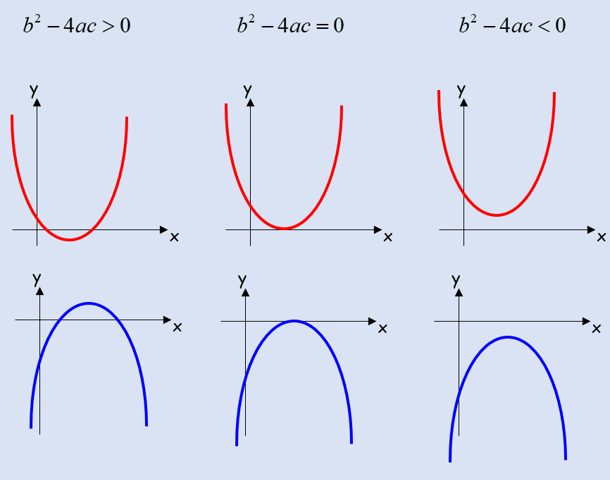

- Find the values of k for which;
x² + kx + 9 = 0
has equal roots.

- Find the values of k for which;
x² + 4x + k = 0
has two distinct real solutions.

2H Modelling with Quadratics

- A spear is thrown over level ground from the top of a tower. The height, $h$, in metres, of the spear above the ground after $t$ seconds is modelled by the function:
$$h\left(t\right)=12.25+14.7t-4.9t^{2}, t≥0$$
- Interpret the meaning of the constant 12.25 in the question

- After how many seconds does the spear hit the ground?

- Write $h(t)$ in the form $A-{B(t-C)}^{2}$, where $A$, $B$ and $C$ are constants to be found.

- Using your answer to part c), or otherwise, find out the maximum height of the spear, and when it reaches this height

