Negative and Fractional Indices

1. Prove that $x^{\frac{1}{2}}=\sqrt{x}$

2. Evaluate ${27}^{-\frac{1}{3}}$

- Evaluate ${32}^{\frac{2}{5}}$

- 4. Simplify ${\left(\frac{1}{9}x^{6}y\right)}^{\frac{1}{2}}$

5. Evaluate ${\left(\frac{27}{8}\right)}^{-\frac{2}{3}}$

6. If $b=\frac{1}{9}a^{2}$, determine $3b^{-2}$ in the form $ka^{n}$ where $k,n$ are constants

Extension
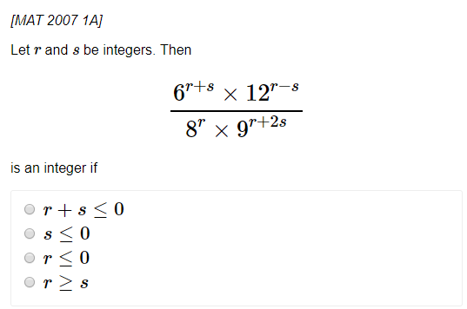

Exercise 1D Page 11

