Lower 6 Chapter 9

Trig Ratios

Chapter Overview

1. Sine/ Cosine Rule

2. Areas of Triangles

3. Trig Graphs

4. Proof of Sine/ Cosine Rule





Sine and Cosine Rule

|  |  |  |
| --- | --- | --- |
| **You have** | **You want** | **Use** |
| #1: Two angle-side opposite pairs | Missing angle or side in one pair | Sine rule |
| #2 Two sides known and a missing side opposite a known angle | Remaining side | Cosine rule |
| #3 All three sides | An angle | Cosine rule |
| #4 Two sides known and a missing side not opposite known angle | Remaining side | Sine rule twice |

The Cosine Rule

Examples:

15

x

115

12

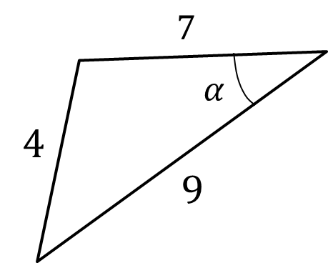



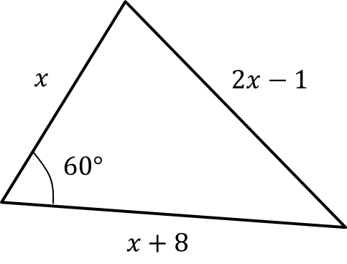

2. Coastguard station $B$ is 8 km, on a bearing of $060°$, from coastguard station $A$. A ship $C$ is 4.8 km on a bearing of $018°$, away from $A$. Calculate how far $C$ is from $B$.

Test Your understanding

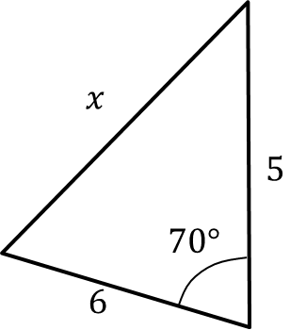

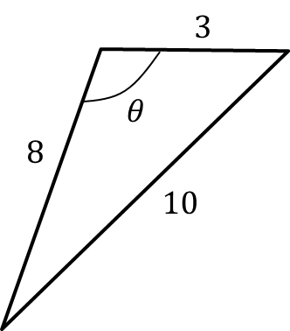

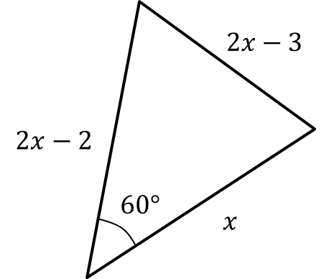

Ex 9A Pg 177

The Sine Rule

Examples:

1. 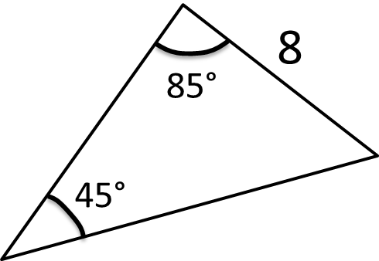

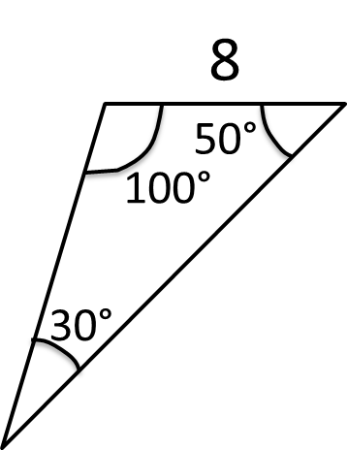

2.

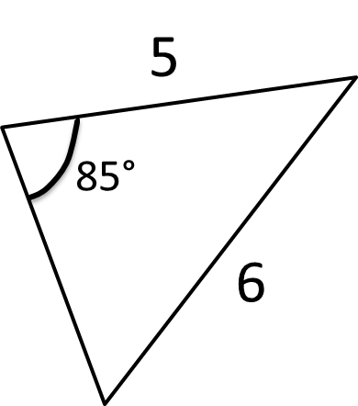3.

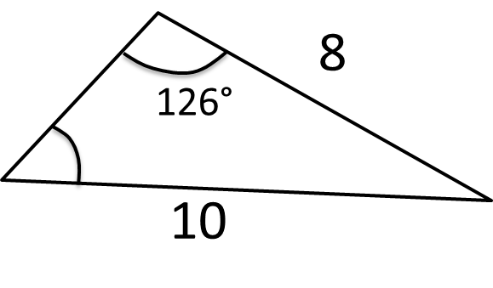4.

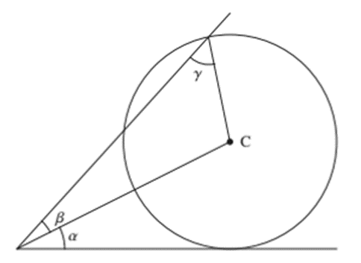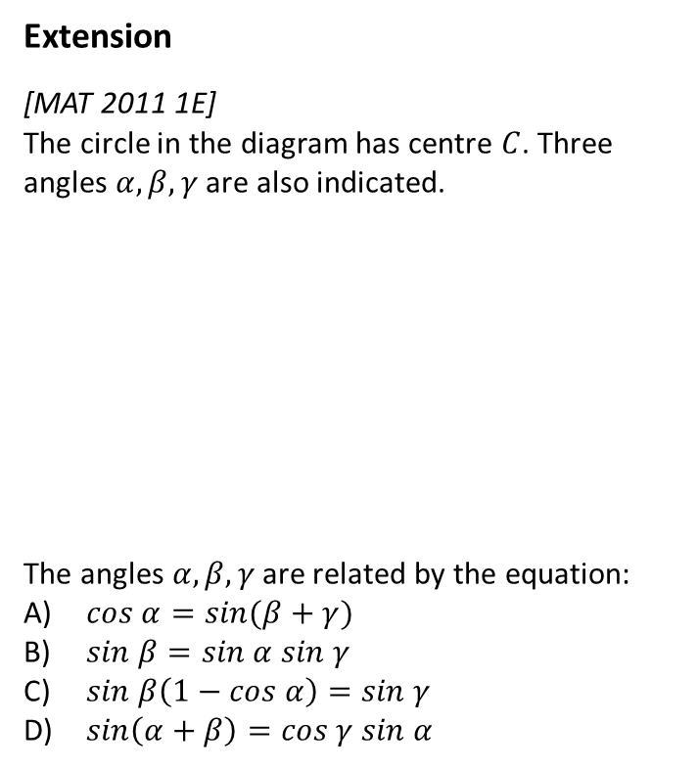

Ex 9B Pg 181

The Ambiguous Case

Example:

Given that the angle $θ$ is obtuse, determine $θ$ and hence determine the length of $x$.

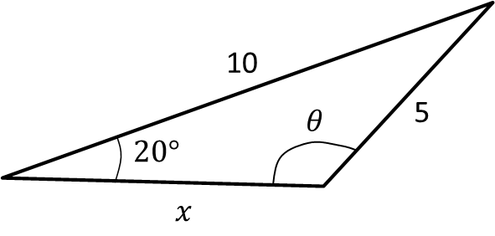

Ex 9C Pg 184

Area of Non Right-Angled Triangles

Test your understanding:

1. The area of this triangle is 10. Determine $x$.

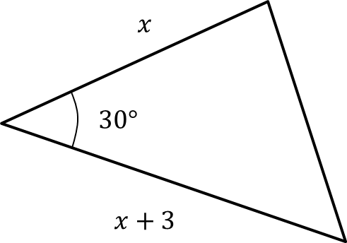

1. The area of this triangle is also 10. If $θ$ is obtuse, determine $θ$.

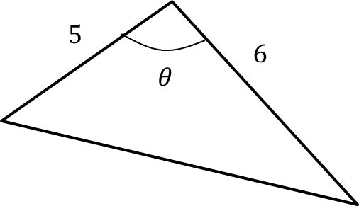

Ex 9D Pg 186

Problem solving with sin/cos rule

Example

The diagram shows the locations of four mobile phone masts in a field, $BC=75 m$. $CD=80m$, angle $BCD=55°$ and angle $ADC=140°$.

In order that the masts do not interfere with each other, they must be at least 70m apart.

Given that $A$ is the minimum distance from $D$, find:

1. The distance $A$ is from $B$
2. The angle $BAD$
3. The area enclosed by the four masts.

Using the sine rule twice:

Test your understanding

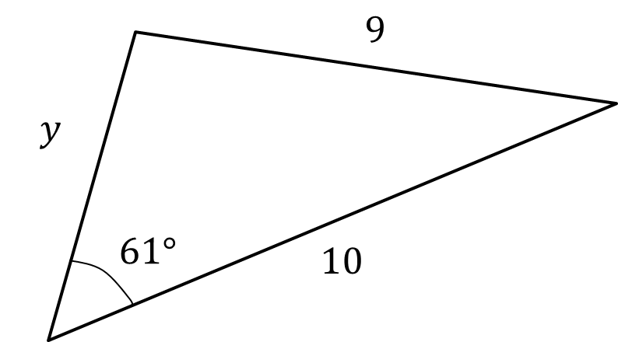

1. 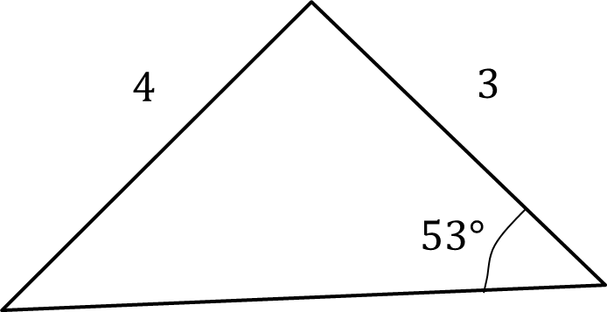

Extension

1. [AEA 2009 Q5a] The sides of the triangle $ABC$ have lengths $BC=a, AC=b$ and $AB=c$, where $a<b<c$. The sizes of the angles $A, B$ and $C$ form an arithmetic sequence.
2. Show that the area of triangle $ABC$ is $ac\frac{\sqrt{3}}{4}$.

Given that $a=2$ and $\sin{A}=\frac{\sqrt{15}}{5}$, find

(ii) the value of $b$,

(iii) the value of $c$.

Ex 9E Pg 189

Trig Graphs

Y = sin x

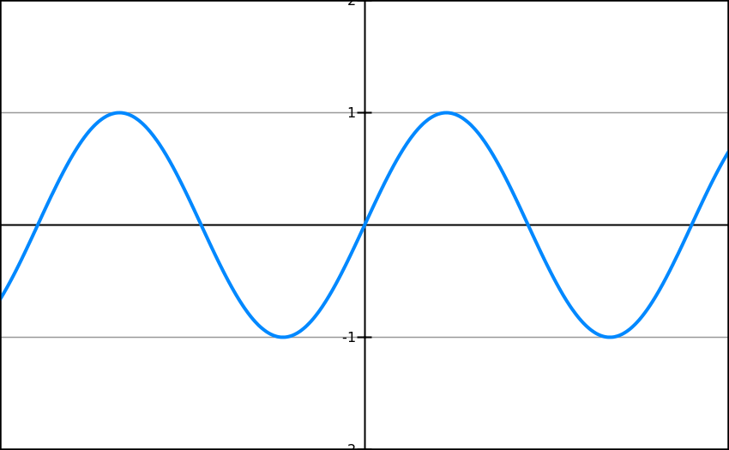

Y = cos x

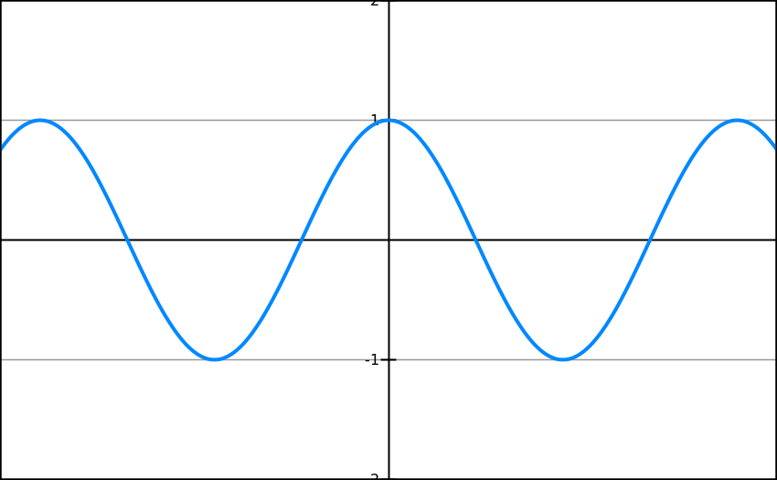

Y = tan x

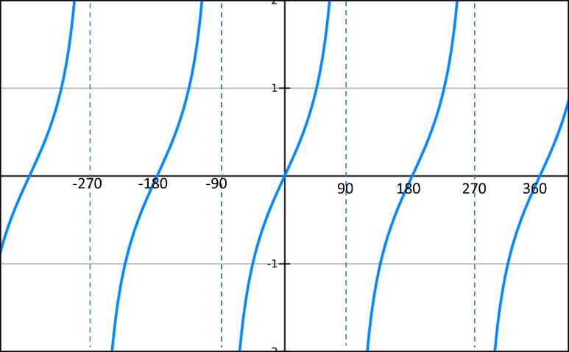

Using trig graphs

Suppose we know that sin(30) = 0.5. By thinking about symmetry in the graph, how could we work out:

Sin(150)

Sin(-30)

Sin(210)



Suppose we know that **cos(60) = 0.5**. By thinking about symmetry in the graph, how could we work out:

Cos(120)

Cos(-60)

Cos(240)



Suppose we know that $\tan\left(30°\right)=\frac{1}{\sqrt{3}}$. By thinking about symmetry in the graph, how could we work out:

Tan(-30)

Tan(150)

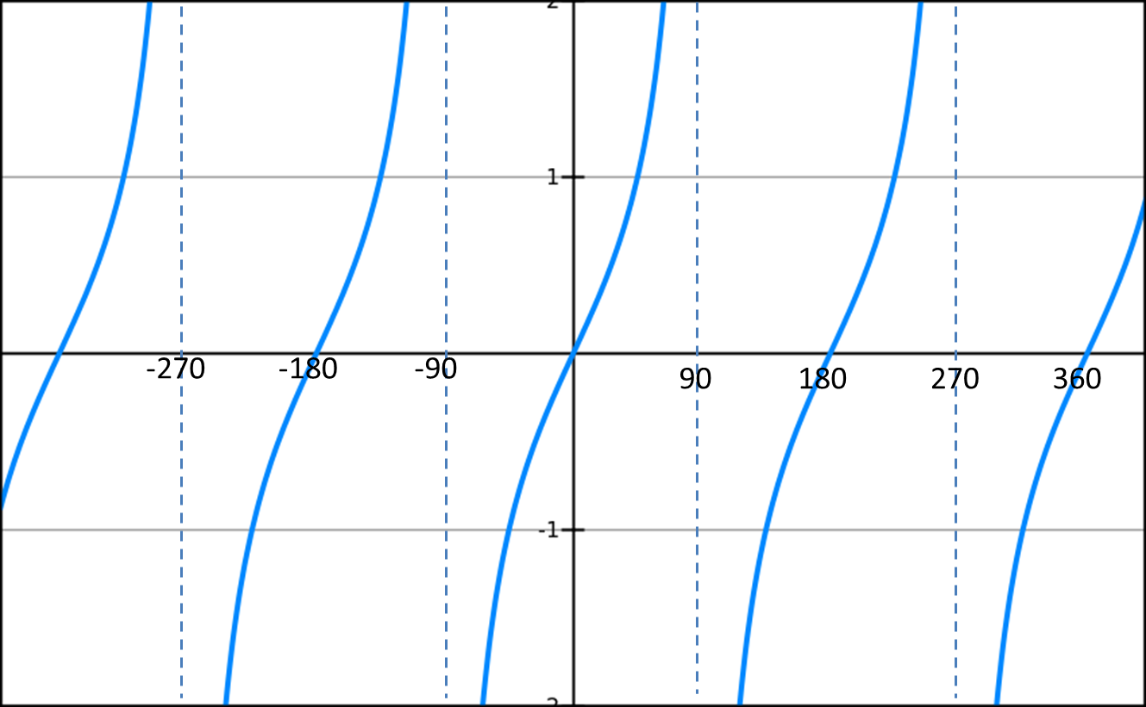

Transforming Trig Graphs

We can use our knowledge of transforming graphs to transform trig graphs.

Recap

Examples

1. Sketch $y=4\sin{x}$, $0≤x≤360°$
2. Sketch $y=\cos\left(x+45°\right)$, $0≤x≤360°$
3. Sketch $y=-\tan{x}$, $0≤x≤360°$
4. Sketch $y=\sin\left(\frac{x}{2}\right)$, $0≤x≤360°$

Extension

*[MAT 2013 1B]* The graph of $y=\sin{x}$ is reflected first in the line $x=π$ and then in the line $y=2$. The resulting graph has equation:



$y=\cos{x}$

$y=2+\sin{x}$

$y=4+\sin{x}$

$y=2-\cos{x}$

*[MAT 2011 1D]* What fraction of the interval $0≤x≤360°$  
 is one (or both) of the inequalities:

$\sin{x}≥\frac{1}{2}, \sin{2x}≥\frac{1}{2}$ true?

*3.*

*MAT 2007 1G]* On which of the axes is a sketch of the graph

$$y=2^{-x}\sin^{2}\left(x^{2}\right)$$

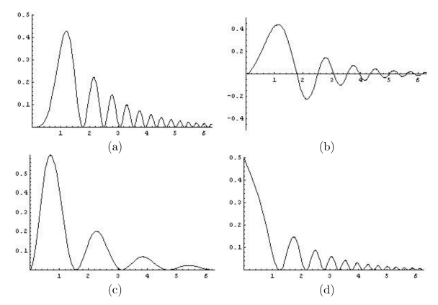

Ex 9F/G Pg 194 – 197.

Proof of Cosine Rule

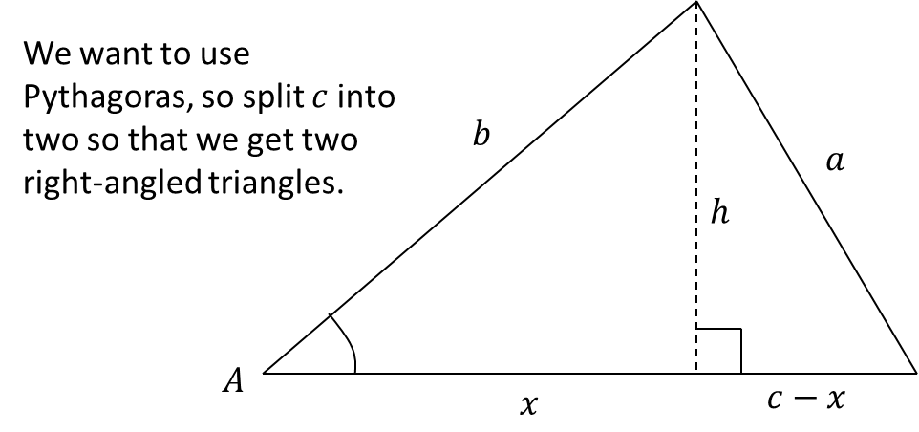

Proof of Sine Rule

