Lower 6 Chapter 8

Binomial Expansion

Chapter Overview

1. Pascal’s Triangle

2. Factorial Notation

3. Binomial Expansion

4. Using Expansions for Estimation



Pascal’s Triangle:

Starter

1. Expand ${\left(a+b\right)}^{0}$
2. Expand ${\left(a+b\right)}^{1}$
3. Expand ${\left(a+b\right)}^{2}$
4. Expand ${\left(a+b\right)}^{3}$
5. Expand ${\left(a+b\right)}^{4}$

What do you notice about the powers of a and b?

Example

Find the expansion of ${\left(2+3x\right)}^{4}$

Example

Find ${\left(1-2x\right)}^{3}$ =

Finding a single term example:

The coefficient of $x^{2}$ in the expansion of ${\left(2-cx\right)}^{5}$ is 720. Find the possible value(s) of the constant $c$.

Test Your Understanding

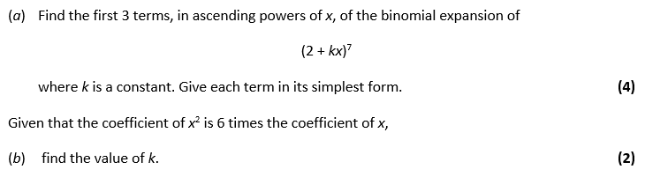

**Extension**

*[MAT 2009 1J]*

The number of pairs of positive integers $x,y$ which solve the equation:

$$x^{3}+6x^{2}y+12xy^{2}+8y^{3}=2^{30}$$

is:

1. 0

$2^{6}$

$2^{9}-1$

Exercise 8A Page 161



$2^{10}+2$

Factorial Notation

Notation:

For example, suppose you had three letters, A, B and C, and wanted to arrange them in a line to form a ‘word’, e.g. ACB or BAC.

* There are 3 choices for the first letter.
* There are then 2 choices left for the second letter.
* There is then only 1 choice left for the last letter.

There are therefore $3×2×1=3!=6$ possible combinations.

**Your calculator can calculate a factorial using the $x!$ button.**

For example, if you are a football team captain and need to choose 4 people from amongst 10 in your class, there are $\left(\begin{matrix}10 \\ 4\end{matrix}\right)=\frac{10!}{4!6! }=210$ possible selections.

*(Note: the $\left(\begin{matrix}10 \\ 4\end{matrix}\right)$ notation is preferable to $10C4$)*

**Use the $nCr$ button on your calculator (your calculator input should display “10C4”)**

Examples:

Calculate the value of the following. You may use the factorial button, but not the nCr button.

1. $5!$ b) $\left(\begin{matrix}5 \\ 3\end{matrix}\right)$
2. $0!$ d) $\left(\begin{matrix}20 \\ 1\end{matrix}\right)$

e) $\left(\begin{matrix}20 \\ 0\end{matrix}\right)$ f) $\left(\begin{matrix}20 \\ 2\end{matrix}\right)$

g) $\left(\begin{matrix}20 \\ 2\end{matrix}\right)$ g) $\left(\begin{matrix}20 \\ 18\end{matrix}\right)$

Exercise 8B Page 162

Binomial Expansion

Example

Find the first 4 terms in the expansion of ${\left(3x+1\right)}^{10}$, in ascending powers of $x$.

Test Your Understanding

Find the first 3 terms in the expansion of ${\left(2-\frac{1}{3}x\right)}^{7}$, in ascending powers of $x$.

Extension

1. [AEA 2013 Q1a] In the binomial expansion of ${\left(1+\frac{12n}{5}x\right)}^{n}$ the coefficients of $x^{2}$ and $x^{3}$ are equal and non-zero.

Find the possible values of .

2. [STEP I 2010 Q5a] By considering the expansion of ${\left(1+x\right)}^{n}$, where $n$ is a positive integer, or otherwise, show that:

$$\left(\begin{matrix}n \\ 0\end{matrix}\right)+\left(\begin{matrix}n \\ 1\end{matrix}\right)+\left(\begin{matrix}n \\ 2\end{matrix}\right)+…+\left(\begin{matrix}n \\ n\end{matrix}\right)=2^{n}$$

Exercise 8C Page 164

Finding a Single Term in the Expansion

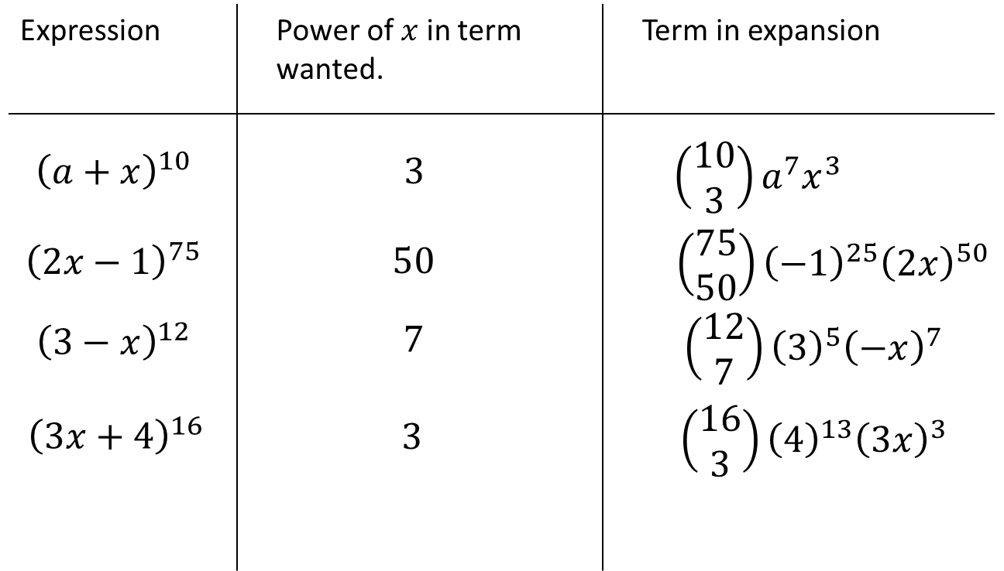

Example

The coefficient of $x^{4}$ in the expansion of ${\left(1+qx\right)}^{10}$ is 3360. Find the possible value(s) of the constant $q$.

Test Your Understanding

In the expansion of ${\left(1+ax\right)}^{10}$, where $a$ is a non-zero constant the coefficient of $x^{3}$ is double the coefficient of $x^{2}$. Find the value of $a$.

Extension

1. *MAT 2014 1G]* Let $n$ be a positive integer. The coefficient of $x^{3}y^{5}$ in the expansion of ${\left(1+xy+y^{2}\right)}^{n}$ equals:




$n$

$2^{n}$

$\left(\begin{matrix}n \\ 3\end{matrix}\right)\left(\begin{matrix}n \\ 5\end{matrix}\right)$

$4\left(\begin{matrix}n \\ 4\end{matrix}\right)$

$\left(\begin{matrix}n \\ 8\end{matrix}\right)$

7. [STEP I 2013 Q6] By considering the coefficient of $x^{r}$ in the series for $\left(1+x\right){\left(1+x\right)}^{n}$, or otherwise, obtain the following relation between binomial coefficients:

Exercise 8D Page 166

$$\left(\begin{matrix}n \\ r\end{matrix}\right)+\left(\begin{matrix}n \\ r-1\end{matrix}\right)=\left(\begin{matrix}n+1 \\ r\end{matrix}\right)$$

Using Expansions for Estimating

Example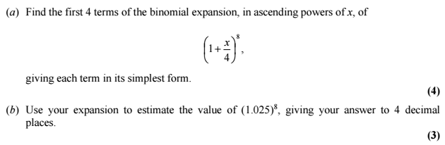

Test Your Understanding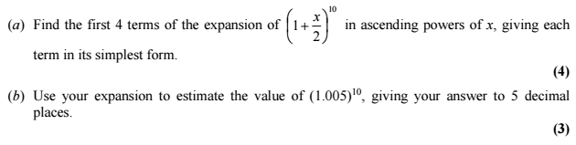

Exercise 8E Page 168