Lower 6 Chapter 5

Linear Graphs

Chapter Overview

1.

2. Parallel and perpendicular lines

3. Lengths and Areas

4. Modelling



1. Linear Graphs

Examples:

1. The point $\left(5,a\right)$ lies on the line with equation $y=3x+2$. Determine the value of .

2. Find the coordinate of the point where the line $2x+y=5$ cuts the $x$-axis.

Test Your Understanding:

Determine where the line $x+2y=3$ crosses both the axes

Gradient

Examples:

Find the gradient of the line between the following sets of points:

1.

2.

3.

4. Show that the points $A\left(3,4\right),B\left(5,5\right),C\left(11,8\right)$ all lie on a straight line.

5. The line joining $\left(2,-5\right)$ to $\left(4,a\right)$ has gradient -1. Work out the value of $a$.

$$y=mx+c$$

Example:

Determine the gradient and $y$-intercept of the line with equation $4x-3y+5=0$

$$ax+by+c=0$$

Example

Express $y=\frac{1}{3}x-\frac{2}{3}$ in the form $ax+by+c=0$, where $a,b,c$ are integers.

Test Your Understanding

Express $y=\frac{2}{5}x+\frac{3}{5}$ in the form $ax+by+c=0$, where $a,b,c$ are integers.

Exercise 5A/B Page 90-93

Equations using one point and the gradient

Example

Find the equation of the line that goes through $\left(3,5\right)$ and has gradient 2.

Quickfire Questions

|  |  |  |
| --- | --- | --- |
| **Gradient** | **Point** | **(Unsimplified) Equation** |
| $$3$$ | $$\left(1,2\right)$$ |  |
| $$5$$ | $$\left(3,0\right)$$ |  |
| $$2$$ | $$\left(-3,4\right)$$ |  |
| $$\frac{1}{2}$$ | $$\left(1,-5\right)$$ |  |
| $$9$$ | $$\left(-4,-4\right)$$ |  |

Finding a line using 2 Points:

Example

1. Find the equation of the line that goes through $\left(4,5\right)$ and $\left(6,2\right)$, giving your equation in the form $ax+by+c=0$.

**Test Your Understanding:**

1. Find the equation of the line that goes through $\left(-1,9\right)$ and $\left(4,5\right)$, giving your equation in the form $ax+by+c=0$.

Exercise 5C Page 94-95

Intersection of Lines:

Example

The diagram shows two lines with equations $y=3x$ and $x+2y=4$, which intersect at the point $P$.

a. Determine the coordinates of $P$.

b. The line $x+2y=4$ intersects the $x$-axis at the point $Q$. Determine the coordinate of $Q$.

$$x$$

$$y$$

$$x+2y=4$$

$$y=3x$$

$$P$$

$$Q$$

$$O$$

Test Your Understanding

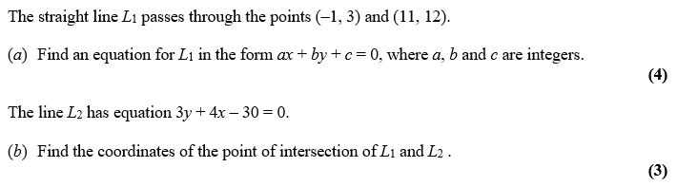

Exercise 5D Page 95

Perpendicular Lines

Quickfire Questions

|  |  |
| --- | --- |
| Gradient | Gradient of Perpendicular Line |
| $$2$$ |  |
| $$-3$$ |  |
| $$\frac{1}{4}$$ |  |
| $$5$$ |  |
| $$-\frac{2}{7}$$ |  |
| $$\frac{7}{5}$$ |  |

Problems

1. A line is goes through the point (9,10) and is perpendicular to another line with equation $y=3x+2$. What is the equation of the line?

2. A line goes through the points $A\left(1,3\right)$ and $B\left(3,-1\right)$. A second line $L_{2}$ is perpendicular to $L_{1}$ and passes through point B. Where does $L_{2}$ cross the x-axis?

3. Are the following lines parallel, perpendicular, or neither?

$$y=\frac{1}{2}x$$

$$2x-y+4=0$$

Test Your Understanding

1. A line goes through the point (4,7) and is perpendicular to another line with equation $y=2x+2$. What is the equation of the line? Put your answer in the form $ax+by+c=0$, where $a,b,c$ are integers.

2. Determine the point .

Extension

1. *[MAT 2004 1D]*

What is the reflection of the point $\left(3,4\right)$ in the line ?

2. *[MAT 2014 1D]* The reflection of the point $\left(1,0\right)$ in the line $y=mx$ has coordinates: (in terms of )

3. *[STEP I 2004 Q6]* The three points $A,B,C$ have coordinates $\left(p_{1},q_{1}\right),\left(p_{2},q_{2}\right)$ and $\left(p_{3},q_{3}\right)$, respectively. Find the point of intersection of the line joining $A$ to the midpoint of $BC$, and the line joining $B$ to the midpoint of $AC$. Verify that this point lies on the line joining $C$ to the midpoint of $AB$.

The point $H$ has coordinates $\left(p_{1}+p_{2}+p_{3},q_{1}+q_{2}+q_{3}\right)$. Show that if the line $AH$ intersects the line $BC$ at right angles, then $p_{2}^{2}+q_{2}^{2}=p_{3}^{2}+q_{3}^{2}$, and write down a similar result if the line $BH$ intersects the line $AC$ at right angles.

Deduce that if $AH$ is perpendicular to $BC$ and also $BH$ is perpendicular to $AC$, then $CH$ is perpendicular to $AB$.

Exercise 5E/F Page 96

Distances between points

Examples

**Find the distance between**

$(3,4)$ and $\left(5,7\right)$

$(5,1)$ and $\left(6,-3\right)$

$(0,-2)$ and $\left(-1,3\right)$

Test Your Understanding

**Find the distance between:**

$(1,10)$ and $\left(4,14\right)$

$(3,-1)$ and $\left(0,1\right)$

$(-4,-2)$ and $\left(-12,4\right)$

**Area of Shapes**

$$x$$

$$y$$

$$x+2y=4$$

$$y=3x$$

$$P$$

$$Q$$

$$O$$

Example 1

The diagram shows two lines with equations $y=3x$

and $x+2y=4$, which intersect at the point $P$.

a)Determine the coordinates of $P$.

b) The line $x+2y=4$ intersects the $x$-axis at the point $Q$. Determine the area of the triangle $OPQ$.

When $y=0, x=4$

$$x$$

$$2y=x+4$$

$$x+y=8$$

$$P$$

$$O$$

$$Q$$

$$R$$

Example 2

a)Determine the length of $PQ$

b) Determine the area $PQR$.

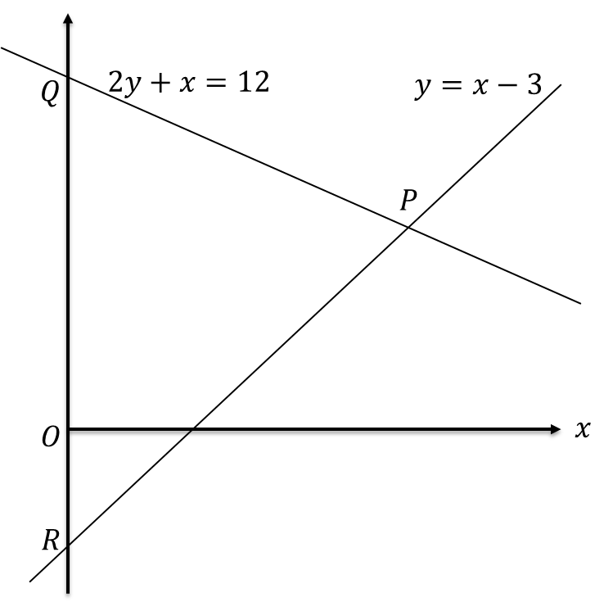**Test Your Understanding:**

a) Determine the coordinate of $P$.

b) Determine the area of $PQR$.

c) Determine the length $PQ$**.**

*Extension*

*[MAT 2001 1C]*

The shortest distance from the origin to the line $3x+4y=25$ is what?

Exercise 5G Page 102/103

**Modelling with Linear Graphs**

Many real life variables have a ‘linear’ relationship, i.e. there is a fixed increase/decrease in one variable each time the other variable goes up by 1 unit.

**Example**

The temperature $y$ at different points on a mountain is recorded at different altitudes $x$.

Suppose we were to use a linear model $y=mx+c$.

a) Determine $m$ and $c$ (you can assume the line goes through $\left(0,70\right)$ and $\left(250,20\right)$.

b) Interpret the meaning of m and c in this context

c) Predict at what altitude the temperature reaches $0°F$

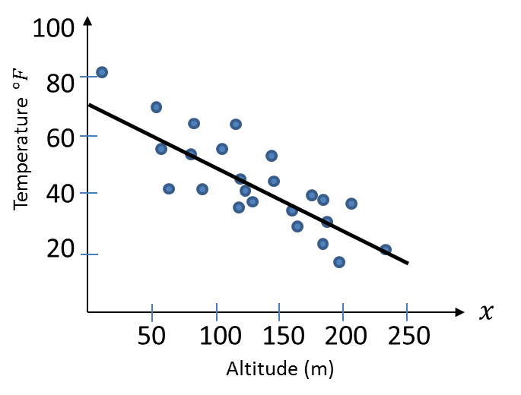

**Evaluating a Model**

Example:

The current population of Bickerstonia is 26000. This year (2017) the population increased by 150. Matt decides to model the population $P$ based on the years $t$ after 2017 by the linear model:

$$P=mt+c$$

Why might this not be a suitable model?

Exercise 5H Page 106/108