Chapter 3
Equations and Inequalities
Chapter Overview
1. Simultaneous Equations
2. Simultaneous Equations Using Graphs
3. Set Builder Notation
4. Solving Inequalities
5. Sketching Inequalities

Simultaneous Equations
Linear Equations:

Example:
Solve the simultaneous equations
$$3x+y=8$$
$$2x-3y=9$$

Method 1 : Elimination Method 2: Substitution

Exercise 3A Page 40

Linear and Quadratic

Example:
Solve the simultaneous equations:
$$x+2y=3$$
$$x^{2}+3xy=10$$

Test Your Understanding:
1. Solve the simultaneous equations: $3x^{2}+y^{2}=21$ and $y=x+1$

Extension:
1.
[MAT 2012 1G] There are positive real numbers $x$ and $y$ which solve the equations $2x+ky=4,x+y=k$
for:
A) All values of $k$;
B) No values of $k$;
C) $k=2$ only;
D) Only $k>-2$

[STEP 2010 Q1] Given that
$$5x^{2}+2y^{2}-6xy+4x-4y≡a{\left(x-y+2\right)}^{2}+b{\left(cx+y\right)}^{2}+d$$
a) Find the values of $a,b,c,d$.
b) Solve the simultaneous equations:
$$5x^{2}+2y^{2}-6xy+4x-4y=9$$
$$6x^{2}+3y^{2}-8xy+8x-8y=14$$(Hint: Can we use the same method in (a) to rewrite the second equation?)
2.
Exercise 3B Page 41

Simultaneous Equations and Graphs

Examples:
1a. On the same axes, draw the graphs of $2x+y=3$and
$y=x^{2}-3x+1$

1b. Use your graph to write down the solutions to the simultaneous equations

1c. What algebraic method could we have used to show the graphs would have intersected twice?

Example 2
a) On the same axes, draw the graphs of:$$y=2x-2 y=x^{2}+4x+1$$
b) Prove algebraically that the lines never meet

Question: The line with equation $y=2x+1$ meets the curve with equation $kx^{2}+2y+\left(k-2\right)=0$ at exactly one point. Given that $k$ is a positive constant:
a) Find the value of $k$.
b) For this value of $k$, find the coordinates of this point of intersection

Exercise 3C Page 45
Set Builder Notation
Recap from GCSE:
- We use curly braces to list the values in a set, e.g. $A=\left\{1,4,6,7\right\}$
- If $A$ and $B$ are sets then $A∩B$ is the intersection of $A$ and $B$, giving a set which has the elements in $A$ and $B$.
- $A∪B$ is the union of $A$ and $B$, giving a set which has the elements in $A$ or in $B$.
- $∅$ is the empty set, i.e. the set with nothing in it.
- Sets can also be infinitely large. $N$ is the set of natural numbers (all positive integers), $Z$ is the set of all integers (including negative numbers and 0) and $R$ is the set of all real numbers (including all possible decimals).
- We write $x∈A$ to mean “$x$ is a member of the set A”. So $x∈R$

- ould mean “$x$ is a real number”.

Examples:

Example

Examples:
1. $\left\{2x :x∈Z\right\}$

2. $\left\{2^{x} :x∈N\right\}$

3. $\left\{xy: x,y are prime\right\}$
Solving Inequalities

Linear inequalities Examples

2. $3\left(x-5\right)≥5-2(x-8)$
$2x+1>5$
1.

$$-x≥2$$

3.

Combining Inequalities
When combining inequalities always draw a number line to help!

Example

Example:
If $x<3$ and $2≤x<4$, what is the combined solution set?

Quadratic Inequalities:

Example

Examples
1. Solve $x^{2}+2x-15>0$

2. Solve $x^{2}+2x-15≤0$

3. Solve $x^{2}+5x≥-4$

4. Solve $x^{2}<9$

Test Your Understanding

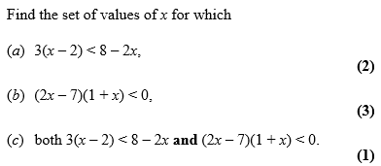

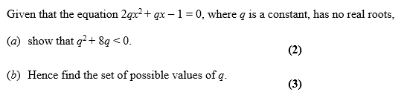

Division by x

Find the set of values for which $\frac{6}{x}>2, x≠0$

Exercise 3D/ 3E Page 47 – 51
45

Sketching Inequalities:

Examples
1. $L_{1}$ has equation $y=12+4x$. $L_{2}$ has equation $y=x^{2}$.
The diagram shows a sketch of $L_{1}$ and $L_{2}$ on the same axes.
- Find the coordinates of $P_{1}$ and $P_{2}$, the points of intersection.
- Hence write down the solution to the inequality
$$6$$
$$-2$$
$$x$$
$$y$$
$$P_{1}$$
$$y=x^{2}$$
$$P_{2}$$
$$y=12+4x$$
$12+4x>x^{2}$.

2. Shade the region that satisfies the inequalities:
$$2y+x<14$$
$$y≥x^{2}-3x-4$$

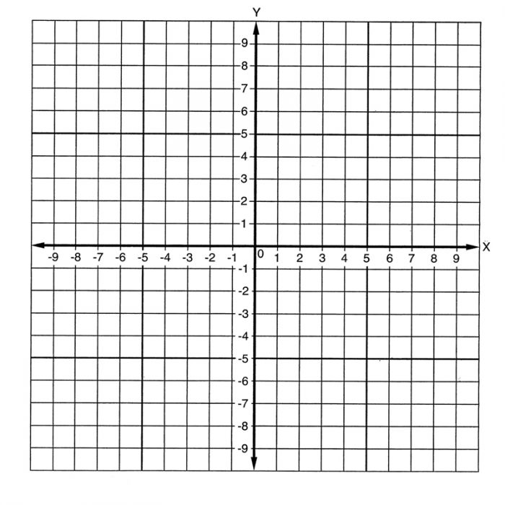

Exercise 3F/ 3G Page 53 – 55
45

