Lower 6 Chapter 10
Trigonometric Identities and Equations

Chapter Overview
- Know exact trig values for $30°, 45°, 60°$ and understand unit circle.
- Use identities $\frac{\sin{x}}{\cos{x}}≡\tan{x}$ and
$\sin^{2}{x}+\cos^{2}{x}≡1$
- Solve equations of the form $\sin\left(nθ\right)=k$ and $\sin\left(θ±α\right)=k$
- Solve equations which are quadratic in sin/cos/tan.

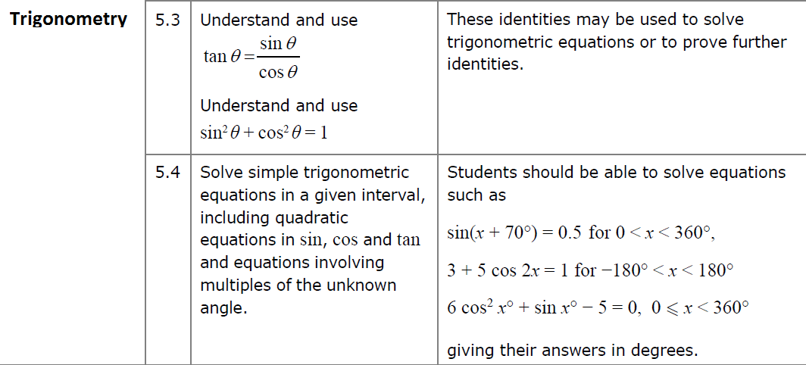

sin/cos/tan of $30°, 45°, 60°$

You will frequently encounter angles of $30°, 60°, 45°$ in geometric problems. Why?

Although you will always have a calculator, you need to know how to derive these.
All you need to remember:
 Draw half a unit square and half an equilateral triangle of side 2.
$$\sin\left(30°\right)=$$
$$\cos\left(30°\right)=$$
$$\tan\left(30°\right)=$$
$$\sin\left(60°\right)=$$
$$\cos\left(60°\right)=$$
$$\tan\left(60°\right)=$$
$$\sin\left(45°\right)=$$
$$\cos\left(45°\right)=$$
$$\tan\left(45°\right)=$$

The Unit Circle and Trigonometry

For values of $θ$ in the range $0<θ<90°$, you know that $\sin{θ}$ and $\cos{θ}$ are lengths on a right-angled triangle:

And what would be the gradient of the bold line (hypotenuse)?

But how do we get the rest of the graph for $sin, cos$ and $tan$ when $90°≤θ≤360°$?

The point $P$ on a unit circle, such that $OP$ makes an angle $θ$ with the positive $x$-axis, has coordinates $\left(\cos{θ},\sin{θ}\right)$.
$OP$has gradient $\tan{θ}$.

Angles are always measured anticlockwise.
We can consider the coordinate P $\left(\cos{θ},\sin{θ}\right)$ as $θ$ increases from 0 to $360°$…
Use the unit circle to determine each value in the table, using either “0”, “+ve”, “-ve”, “1”, “-1” or “undefined”.
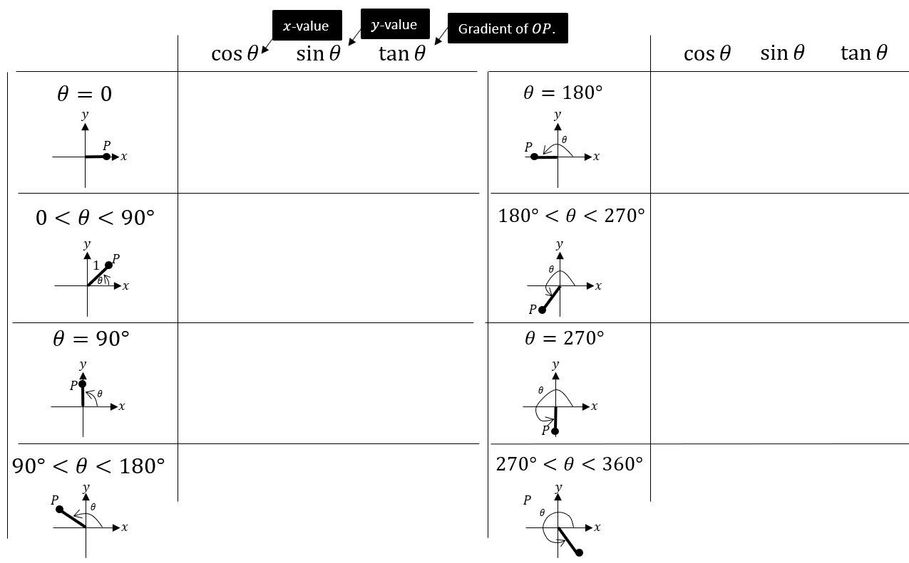

The unit circle explains the behaviour of the trigonometric graphs beyond $90°$.
However, the easiest way to remember whether $\sin\left(x\right),\cos\left(x\right),\tan\left(x\right)$ are positive or negative is to just do a very quick sketch (preferably mentally!) of the corresponding graph.
Note: The textbook uses something called ‘CAST diagrams’. We will not be using them in this booklet, but you may wish to look at this technique as an alternative approach to various problems in the chapter.

A Few Trigonometric Angle Laws
The following are all easily derivable using a quick sketch of a trigonometric graph, and are merely a convenience so you don’t always have to draw out a graph every time.
You are highly encouraged to memorise these so that you can do exam questions faster.
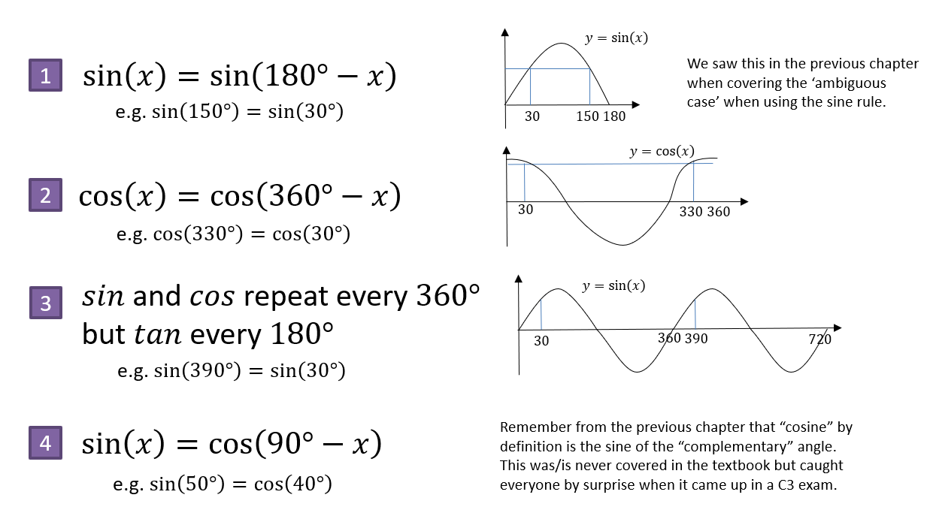

Examples

Without a calculator, work out the value of each below:
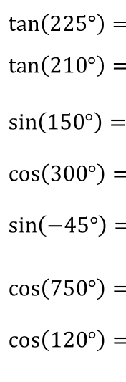
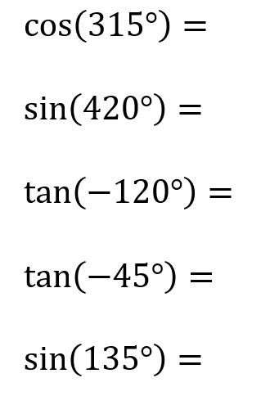

Exercise 10A and B Pg 207 and 209

AD Page 11
Trigonometric identities
$$tan θ=\frac{sin θ}{cos θ}$$

$$sin^{2}θ+cos^{2}θ=1$$

Examples
Prove that $1-\tan{θ}\sin{θ}\cos{θ}≡\cos^{2}{θ}$

Prove that $\tan{θ}+\frac{1}{\tan{θ}}≡\frac{1}{\sin{θ}\cos{θ}}$

Simplify $5-5\sin^{2}{θ}$

Test your understanding
Prove that $\frac{\tan{x}\cos{x}}{\sqrt{1-\cos^{2}{x}}}≡1$

Prove that $\frac{\cos^{4}{θ}-\sin^{4}{θ}}{\cos^{2}{θ}}≡1-\tan^{2}{θ}$

Prove that $\tan^{2}{θ}≡\frac{1}{\cos^{2}{θ}}-1$

Exercise 10C Pg 211/212

AD Page 11
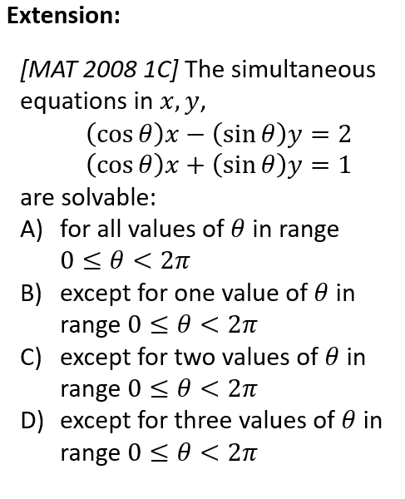

Solving trigonometric equations
Solve $\sin{θ}=\frac{1}{2}$ in the interval $0≤θ≤360°$.

Solve $5\tan{θ}=10$ in the interval $-180°≤θ<180°$

Solve $\sin{θ}=-\frac{1}{2}$ in the interval $0≤θ≤360°$.

Solve $\sin{θ}=\sqrt{3}\cos{θ}$ in the interval $0≤θ≤360°$.

Solve $2\cos{θ}=\sqrt{3}$ in the interval $0≤θ≤360°$.

Solve $\sqrt{3}\sin{θ}=\cos{θ}$ in the interval $-180°≤θ≤180°$.

Exercise 10D Pg 215/216

AD Page 11
Harder equations
Solve $\cos{3x=-\frac{1}{2}}$ in the interval $0≤x≤360°$.

Solve $\sin{(2x+30°)=\frac{1}{\sqrt{2}}}$ in the interval $0≤x≤360°$.

Solve $\sin{x}=2\cos{x}$ in the interval $0≤x<300°$

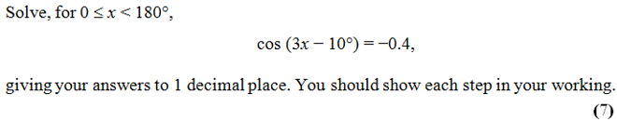

Exercise 10E Pg 218/219

AD Page 11
Quadratics in sin/cos/tan
Solve $5\sin^{2}{x}+3\sin{x}-2=0$ in the interval $0≤x≤360°$.

Solve $\tan^{2}{θ}=4$ in the interval $0≤x≤360°$.

Solve $2\cos^{2}{x}+9\sin{x}=3\sin^{2}{x}$ in the interval $-180°≤x≤180°$.

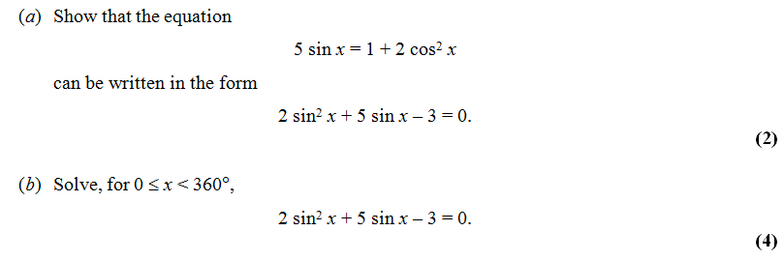

Exercise 10F Pg 221/222

AD Page 11
