A Level Mathematics

Chapter 1

Algebraic Expressions

Chapter Overview

1. Basic Index Laws

2. Negative/ Fractional Indices

3. Factorise Quadratics and Cubics

4. Expanding Brackets

5. Surds



Basic Index Laws

Examples

1. Simplify

2. Simplify

3. Simplify

4. Simplify $\frac{x^{3}-2x}{3x^{2}}$ ( 2 methods)

Test Your Understanding:

1. Simplify ${\left(\frac{2a^{5}}{a^{2}}\right)}^{2}×3a$ 2. Simplify $\frac{2x+x^{5}}{4x^{3}}$

3.Expand and simplify $2x\left(3-x^{2}\right)-4x^{3}\left(3-x\right)$

4.Simplify $2^{x}×3^{x}$

Extension

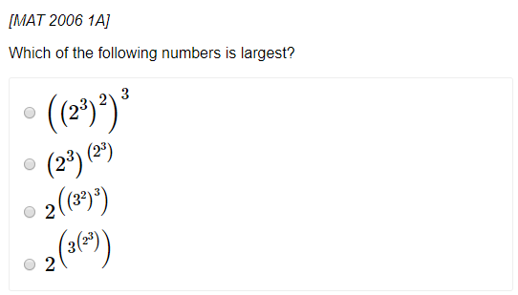

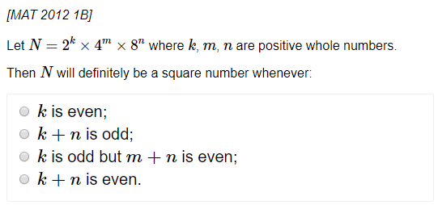

Exercise 1A Page 3

Negative and Fractional Indices

1. Prove that $x^{\frac{1}{2}}=\sqrt{x}$ 2. Evaluate ${27}^{-\frac{1}{3}}$

1. Evaluate ${32}^{\frac{2}{5}}$ 4. Simplify

5. Evaluate

6. If , determine $3b^{-2}$ in the form $ka^{n}$ where $k,n$ are constants

Extension

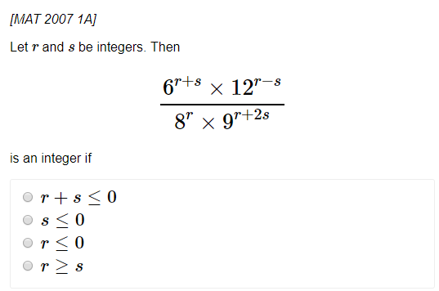

Exercise 1D Page 11

Brackets: Expanding

Example: $\left(x+1\right)\left(x+2\right)\left(x+3\right)$

Questions

1. Expand and simplify

2. Expand and simplify:

3. Expand and simplify:

$${\left(2x-1\right)}^{3}$$

Extension

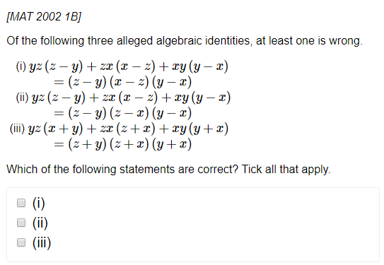

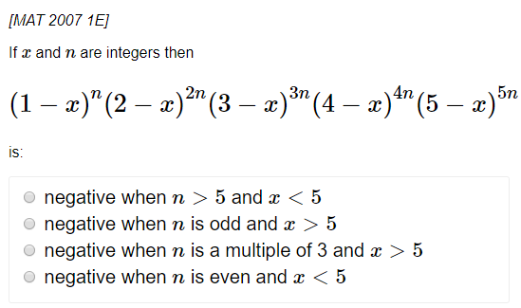

Brackets: Factorising

Examples:

1. 2.

3. 4.

5.

Test your understanding: Factorise completely

1. 2.

3. 4.

Exercise 1C Page 8

Surds:

1. $\sqrt{3}×2$ $2. 3\sqrt{5}×2\sqrt{5}$

3. $\sqrt{8}$ $4. \sqrt{12}+\sqrt{27}$

5. $\left(\sqrt{8}+1\right)\left(\sqrt{2}-3\right)$

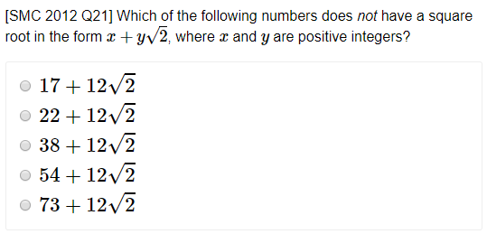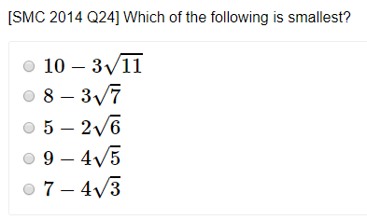Extension:

Exercise 1E Page 11

Rationalising the denominator:

Examples:

3. 4.

Test your understanding:

$\frac{12}{\sqrt{3}}$

$\frac{2}{\sqrt{6}}$

$\frac{4\sqrt{2}}{\sqrt{8}}$

More Complicated Examples:

1. 2.

3.

Test Your Understanding: Rationalise the denominator and simplify

1.

2.

3. Solve

Give your answer in the form $a+b\sqrt{3}$ where $a$ and $b$ are integers.

Exercise 1F Page 15