Brackets: Expanding
Example: $\left(x+1\right)\left(x+2\right)\left(x+3\right)$

Questions
1. Expand and simplify
$$\left(x+5\right)\left(x-2\right)\left(x+1\right)$$

2. Expand and simplify:
$$2\left(x-3\right)\left(x-4\right)$$

3. Expand and simplify:
$${\left(2x-1\right)}^{3}$$

Extension
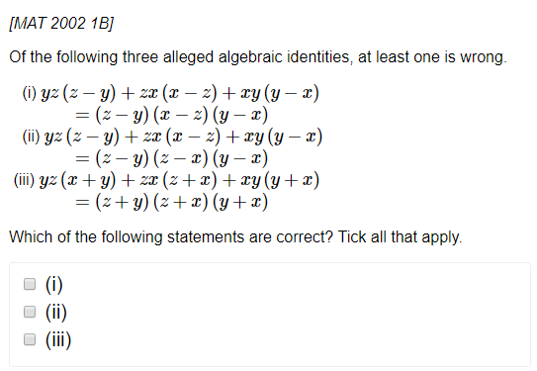
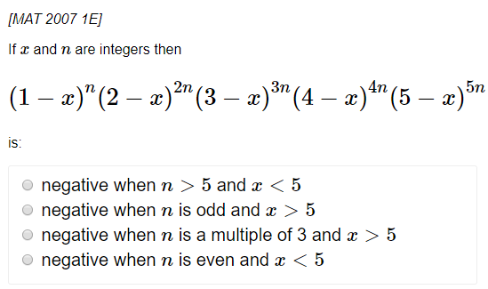
Exercise 1C Page 8
Brackets: Factorising

Examples:
1. $x^{2}-5x-14$

2. ${2x}^{2}+5x-12$

3. $4x^{2}-9$

4. $x^{3}-x$

5. $x^{3}+3x^{2}+2x$

Test your understanding: Factorise completely
1. $6x^{2}+x-2$

2. $x^{3}-7x^{2}+12x$

3. $x^{4}-1$

4. $x^{3}-1$

Exercise 1C Page 8

