Surds:

- $\sqrt{3}×2$

- $3\sqrt{5}×2\sqrt{5}$

- $\sqrt{8}$

- $\sqrt{12}+\sqrt{27}$

5. $\left(\sqrt{8}+1\right)\left(\sqrt{2}-3\right)$

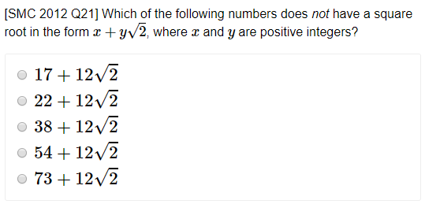
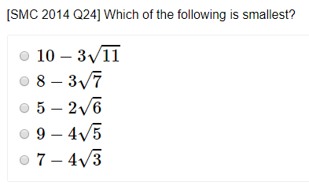
Extension:

Exercise 1E Page 11

Rationalising the denominator:

Examples:
$$1. \frac{3}{\sqrt{2}}$$

$2.$ $\frac{6}{\sqrt{3}}$

3. $\frac{7}{\sqrt{7}}$

4. $\frac{15}{\sqrt{5}}+\sqrt{5}$

Test your understanding:
$\frac{12}{\sqrt{3}}$

$\frac{2}{\sqrt{6}}$

$\frac{4\sqrt{2}}{\sqrt{8}}$

More Complicated Examples:
1. $\frac{3}{\sqrt{6}-2}$

2. $\frac{4}{\sqrt{3}+1}$

3. $\frac{3\sqrt{2}+4}{5\sqrt{2}-7}$

Test Your Understanding: Rationalise the denominator and simplify
1. $\frac{4}{\sqrt{5}-2}$

2. $\frac{2\sqrt{3}-1}{3\sqrt{3}+1}$

3. Solve $y\left(\sqrt{3}-1\right)=8$
Give your answer in the form $a+b\sqrt{3}$ where $a$ and $b$ are integers.

Exercise 1F Page 15

