Transforming Trig Graphs
We can use our knowledge of transforming graphs to transform trig graphs.

Recap

Examples
- Sketch $y=4\sin{x}$, $0≤x≤360°$

- Sketch $y=\cos\left(x+45°\right)$, $0≤x≤360°$

- Sketch $y=-\tan{x}$, $0≤x≤360°$

- Sketch $y=\sin\left(\frac{x}{2}\right)$, $0≤x≤360°$

Extension

[MAT 2013 1B] The graph of $y=\sin{x}$ is reflected first in the line $x=π$ and then in the line $y=2$. The resulting graph has equation:
- $y=\cos{x}$
- $y=2+\sin{x}$
- $y=4+\sin{x}$
- $y=2-\cos{x}$

[MAT 2011 1D] What fraction of the interval
$0≤x≤360°$ is one (or both) of the inequalities:
$\sin{x}≥\frac{1}{2}, \sin{2x}≥\frac{1}{2}$ true?

3.
MAT 2007 1G] On which of the axes is a sketch of the graph
$$y=2^{-x}\sin^{2}\left(x^{2}\right)$$

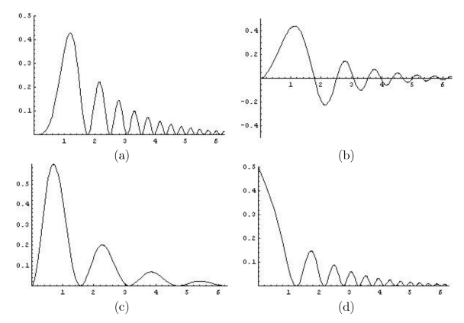

Ex 9F/G Pg 194 – 197.

