Trig Graphs

Y = sin x
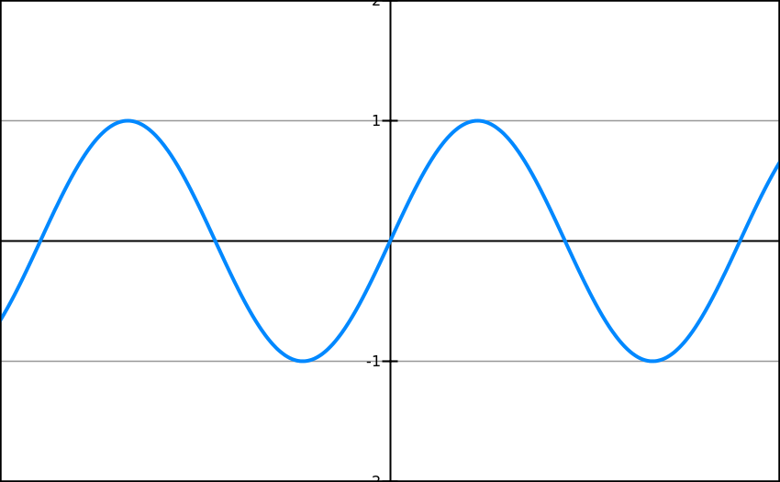

Y = cos x
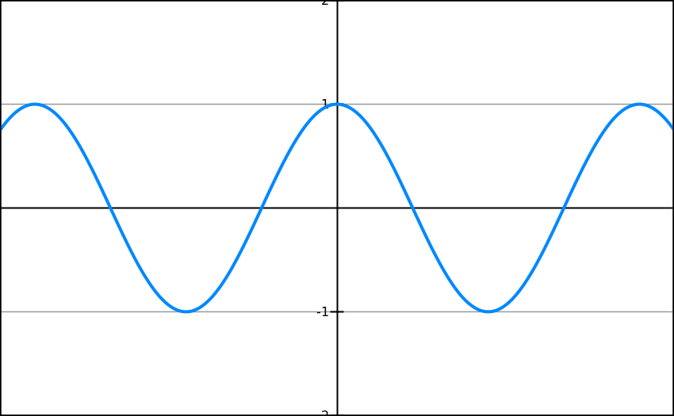

Y = tan x
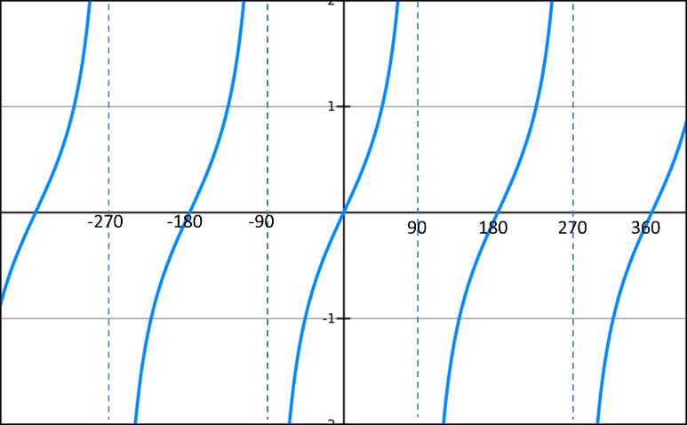

Using trig graphs
Suppose we know that sin(30) = 0.5. By thinking about symmetry in the graph, how could we work out:

Sin(150)

Sin(-30)

Sin(210)

Suppose we know that cos(60) = 0.5. By thinking about symmetry in the graph, how could we work out:

Cos(120)

Cos(-60)

Cos(240)

Suppose we know that $\tan\left(30°\right)=\frac{1}{\sqrt{3}}$. By thinking about symmetry in the graph, how could we work out:

Tan(-30)

Tan(150)

