Problem solving with sin/cos rule

Example
The diagram shows the locations of four mobile phone masts in a field, $BC=75 m$. $CD=80m$, angle $BCD=55°$ and angle $ADC=140°$.
In order that the masts do not interfere with each other, they must be at least 70m apart.
Given that $A$ is the minimum distance from $D$, find:
- The distance $A$ is from $B$
- The angle $BAD$
- The area enclosed by the four masts.

Using the sine rule twice:

Test your understanding

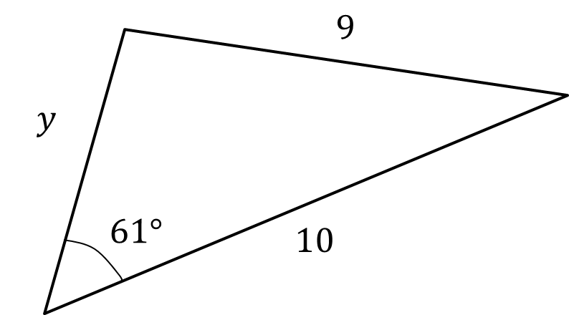

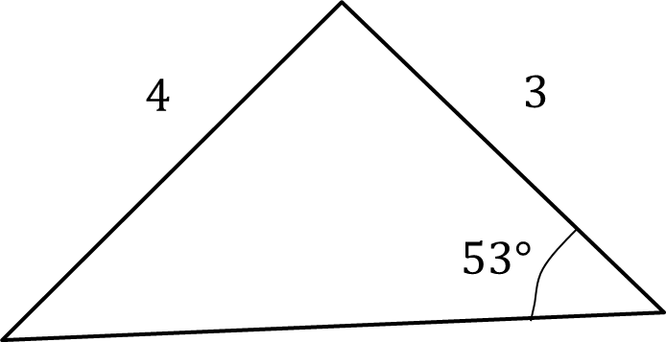

Extension

- [AEA 2009 Q5a] The sides of the triangle $ABC$ have lengths $BC=a, AC=b$ and $AB=c$, where $a<b<c$. The sizes of the angles $A, B$ and $C$ form an arithmetic sequence.
- Show that the area of triangle $ABC$ is $ac\frac{\sqrt{3}}{4}$.
Given that $a=2$ and $\sin{A}=\frac{\sqrt{15}}{5}$, find
(ii) the value of $b$,
(iii) the value of $c$.

Ex 9E Pg 189

