Area of Non Right-Angled Triangles

Test your understanding:
- The area of this triangle is 10. Determine $x$.
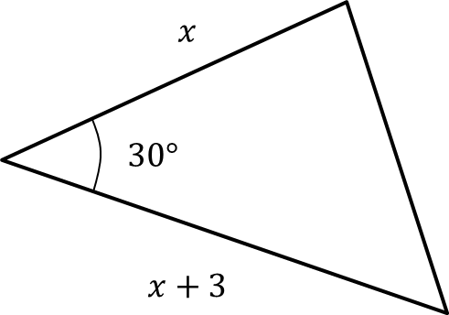

- The area of this triangle is also 10. If $θ$ is obtuse, determine $θ$.

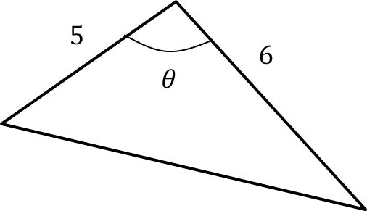
Ex 9D Pg 186

