The Ambiguous Case

Example:
Given that the angle $θ$ is obtuse, determine $θ$ and hence determine the length of $x$.
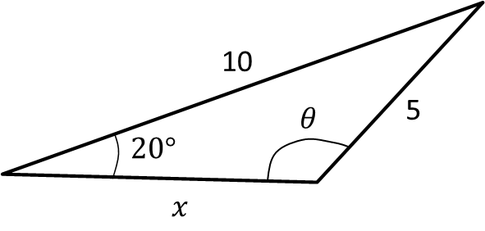

Ex 9C Pg 184

