Lower 6 Chapter 9

Trig Ratios

Chapter Overview

1. Sine/ Cosine Rule

2. Areas of Triangles

3. Trig Graphs

4. Proof of Sine/ Cosine Rule





Sine and Cosine Rule

|  |  |  |
| --- | --- | --- |
| **You have** | **You want** | **Use** |
| #1: Two angle-side opposite pairs | Missing angle or side in one pair | Sine rule |
| #2 Two sides known and a missing side opposite a known angle | Remaining side | Cosine rule |
| #3 All three sides | An angle | Cosine rule |
| #4 Two sides known and a missing side not opposite known angle | Remaining side | Sine rule twice |

The Cosine Rule

Examples:

Proof of Cosine Rule

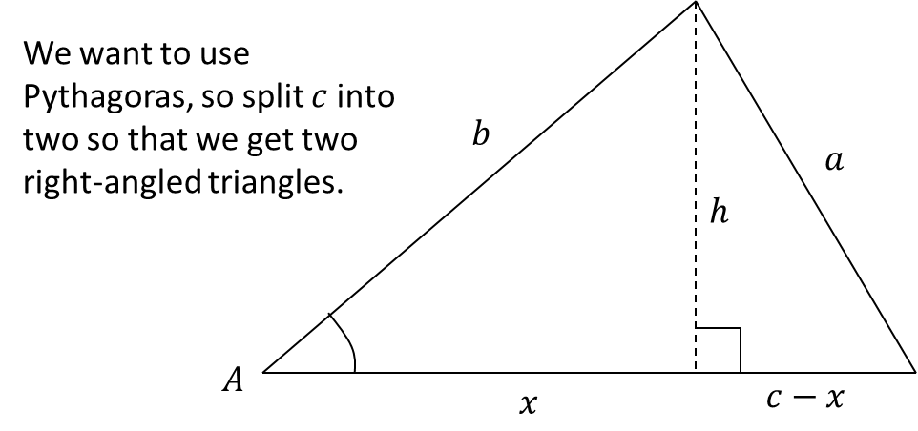

1.

15

x

115

12

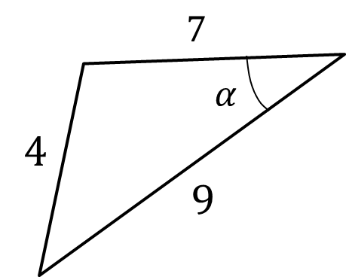



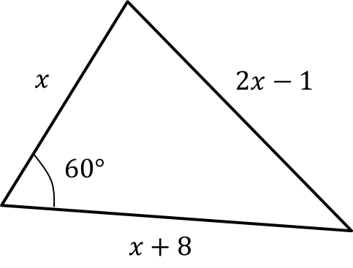

2. Coastguard station $B$ is 8 km, on a bearing of $060°$, from coastguard station $A$. A ship $C$ is 4.8 km on a bearing of $018°$, away from $A$. Calculate how far $C$ is from $B$.

Test Your understanding

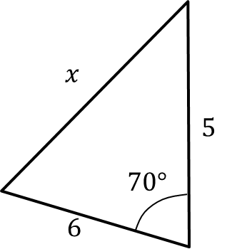

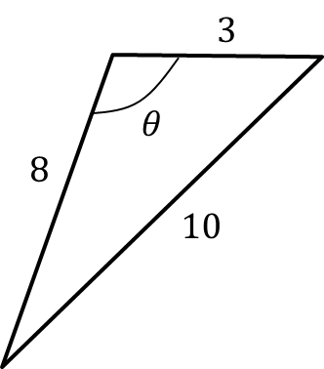

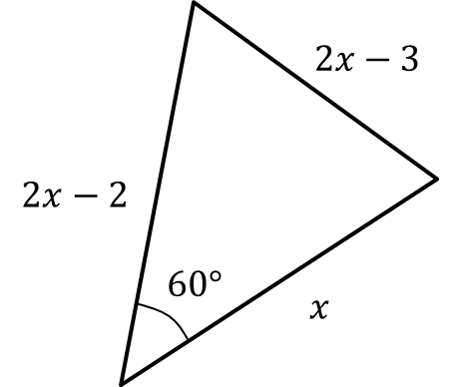

Ex 9A Pg 177