Using Expansions for Estimating
Example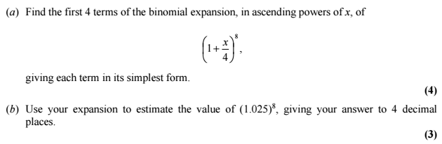

Test Your Understanding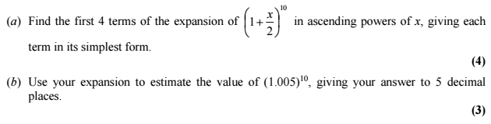

Exercise 8E Page 168

