Finding a Single Term in the Expansion

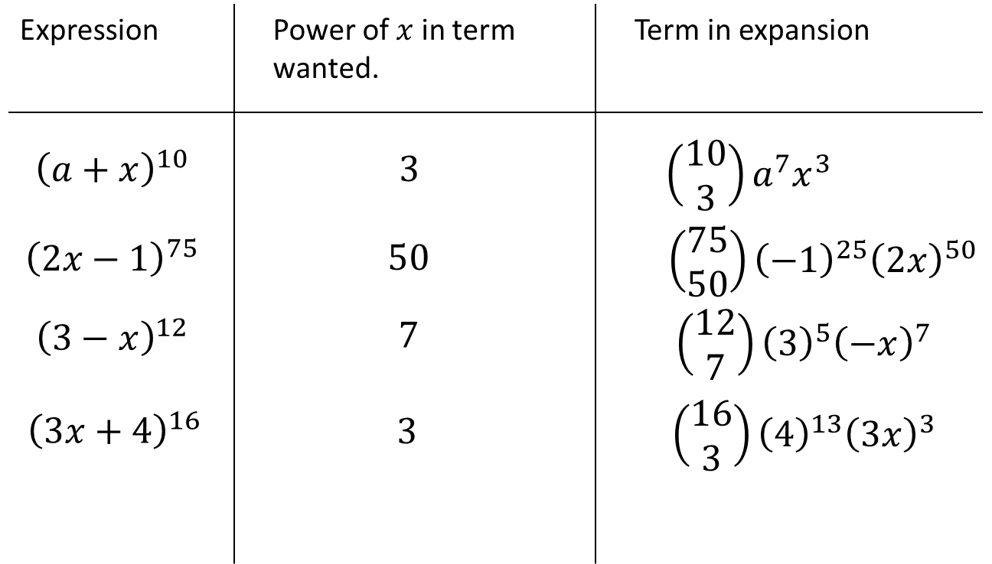

Example
The coefficient of $x^{4}$ in the expansion of ${\left(1+qx\right)}^{10}$ is 3360. Find the possible value(s) of the constant $q$.

Test Your Understanding
In the expansion of ${\left(1+ax\right)}^{10}$, where $a$ is a non-zero constant the coefficient of $x^{3}$ is double the coefficient of $x^{2}$. Find the value of $a$.

Extension
- MAT 2014 1G] Let $n$ be a positive integer. The coefficient of $x^{3}y^{5}$ in the expansion of ${\left(1+xy+y^{2}\right)}^{n}$ equals:
- $n$
- $2^{n}$
- $\left(\begin{matrix}n \\ 3\end{matrix}\right)\left(\begin{matrix}n \\ 5\end{matrix}\right)$
- $4\left(\begin{matrix}n \\ 4\end{matrix}\right)$
- $\left(\begin{matrix}n \\ 8\end{matrix}\right)$

- [STEP I 2013 Q6] By considering the coefficient of $x^{r}$ in the series for $\left(1+x\right){\left(1+x\right)}^{n}$, or otherwise, obtain the following relation between binomial coefficients:
Exercise 8D Page 166
$$\left(\begin{matrix}n \\ r\end{matrix}\right)+\left(\begin{matrix}n \\ r-1\end{matrix}\right)=\left(\begin{matrix}n+1 \\ r\end{matrix}\right)$$

