Lower 6 Chapter 8

Binomial Expansion

Chapter Overview

1. Pascal’s Triangle

2. Factorial Notation

3. Binomial Expansion

4. Using Expansions for Estimation



Pascal’s Triangle:

Starter

1. Expand ${\left(a+b\right)}^{0}$
2. Expand ${\left(a+b\right)}^{1}$
3. Expand ${\left(a+b\right)}^{2}$
4. Expand ${\left(a+b\right)}^{3}$
5. Expand ${\left(a+b\right)}^{4}$

What do you notice about the powers of a and b?

Example

Find the expansion of ${\left(2+3x\right)}^{4}$

Example

Find ${\left(1-2x\right)}^{3}$ =

Finding a single term example:

The coefficient of $x^{2}$ in the expansion of ${\left(2-cx\right)}^{5}$ is 720. Find the possible value(s) of the constant $c$.

Test Your Understanding

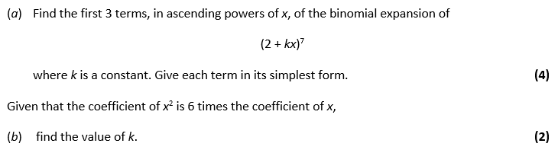

**Extension**

*[MAT 2009 1J]*

The number of pairs of positive integers $x,y$ which solve the equation:

$$x^{3}+6x^{2}y+12xy^{2}+8y^{3}=2^{30}$$

is:

1. 0

$2^{6}$

$2^{9}-1$

Exercise 8A Page 161

$2^{10}+2$