The Factor Theorem

Examples
1. Show that $(x-2)$ is a factor of $x^{3}+x^{2}-4x-4$.

2. Fully factorise $2x^{3}+x^{2}-18x-9$.

Using the factor theorem to find unknown coefficients:

1. Given that $2x+1$ is a factor of $6x^{3}+ax^{2}+1$, determine the value of $a$.

Test your understanding

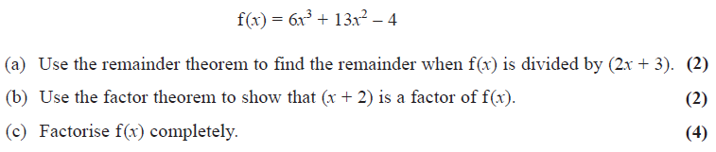

2. Given that $3x-1$ is a factor of $3x^{3}+11x^{2}+ax+1$, determine the value of $a$.

Extension
1. [MAT 2006 1E] The cubic $x^{3}+ax+b$ has both $\left(x-1\right)$ and $\left(x-2\right)$ has factors. Determine the values of $a$ and $b$.

2. [MAT 2009 1I] The polynomial $n^{2}x^{2n+3}-25nx^{n+1}+150x^{7}$ has $x^{2}-1$ as a factor
- for no values of $n$;
- for $n=10$ only;
- for $n=15$ only;
- for $n=10$ and $n=15$ only.

The remainder theorem states that if $f(x)$ is divided by $(x-a)$, the remainder is $f(a)$. This similarly works whenever $a$ makes the divisor 0.
(No longer required for A Level)

3. [MAT 2013 1G] Let $n≥2$ be an integer and $p_{n}\left(x\right)$ be the polynomial
$$p_{n}\left(x\right)=\left(x-1\right)+\left(x-2\right)+…+(x-n)$$
What is the remainder, in terms of $n$, when $p_{n}\left(x\right)$ is divided by $p_{n-1}\left(x\right)$?

Exercise 7C Page 145

