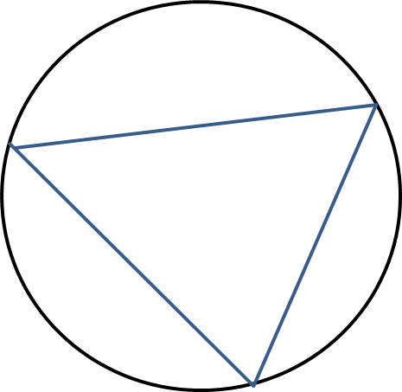
Triangles in Circles

- The triangle inscribes the circle.
(A shape inscribes another if it is inside and its boundaries touch but do not intersect the outer shape)
- The circle circumscribes the triangle.
- If the circumscribing shape is a circle, it is known as the circumcircle of the triangle.
- The centre of a circumcircle is known as the circumcentre.

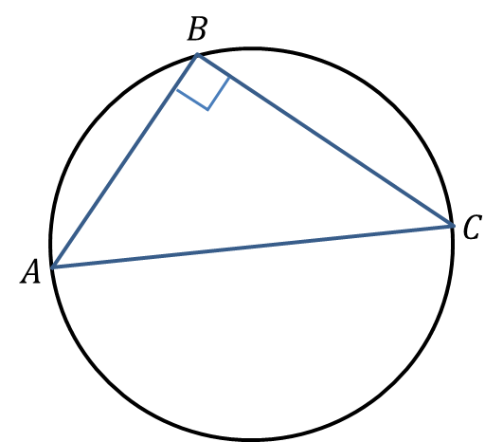

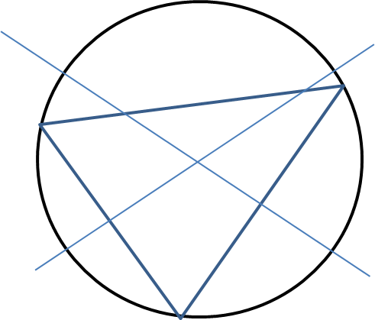

Examples
1. The points $A\left(-8,1\right), B\left(4,5\right),C\left(-4,9\right)$ lie on a circle.
a) Show that $AB$ is a diameter of the circle.

2. The points $A\left(0,2\right), B\left(2,0\right),C\left(8,18\right)$ lie on the circumference of a circle. Determine the equation of the circle.

Extension
[STEP 2009 Q8 Edited] If equation of the circle $C$ is ${\left(x-2t\right)}^{2}+{\left(y-t\right)}^{2}=t^{2}$, where $t$ is a positive number, it can be shown that $C$ touches the line $y=0$ as well as the line $3y=4x$.
Find the equation of the incircle of the triangle formed by the lines $y=0$, $3y=4x$ and $4y+3x=15$.
Note: The incircle of a triangle is the circle, lying totally inside the triangle, that touches all three sides.

Exercise 6F Page 131

