Tangents, chords and perpendicular bisectors
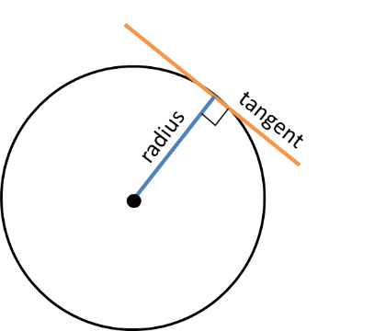
Reminder:

The perpendicular bisector of any chord passes through the centre of the circle.
The tangent is perpendicular to the radius (at the point of intersection).

Why are these useful?

Examples
1. The circle $C$ has equation ${\left(x-3\right)}^{2}+{\left(y-7\right)}^{2}=100$.
- Verify the point $P\left(11,1\right)$ lies on $C$.
- Find an equation of the tangent to $C$ at the point $P$, giving your answer in the form $ax+by+c=0$

2. A circle $C$ has equation ${\left(x-4\right)}^{2}+{\left(y+4\right)}^{2}=10$. The line $l$ is a tangent to the circle and has gradient -3. Find two possible equations for $l$, giving your answers in the form $y=mx+c$.

Finding the centre of a circle
Example:
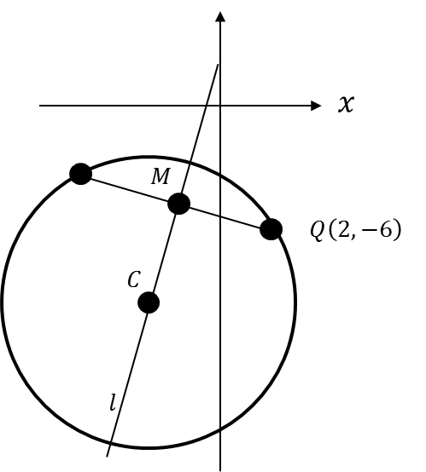
The points $P$ and $Q$ lie on a circle with centre $C$, as shown in the diagram. The point $P$ has coordinates $(-8,-2)$ and the point $Q$ has coordinates $\left(2,-6\right)$. $M$ is the midpoint of the line segment $PQ$.
The line $l$ passes through the points $M$ and $C$.
a) Find an equation for $l$.
$$P\left(-8,-2\right)$$

b) Given that the $y$-coordinate of $C$ is -9:
i) show that the $x$-coordinate of $C$ is -5.
ii) find an equation of the circle.

Test Your Understanding
1. A circle has centre $C\left(3,5\right)$, and goes through the point $P(6,9)$. Find the equation of the tangent of the circle at the point $P$, giving your equation in the form $ax+by+c=0$ where $a,b,c$ are integers.

2. A circle passes through the points $A(0,0)$ and $B\left(4,2\right)$. The centre of the circle has $x$ value -1. Determine the equation of the circle.

Extension
1. MAT 2012 1A] Which of the following lines is a tangent to the circle with equation
$x^{2}+y^{2}=4$?
- $x+y=2$
- $y=x-2\sqrt{2}$
- $x=\sqrt{2}$
- $y=\sqrt{2}-x$

2. [AEA 2006 Q4] The line with equation $y=mx$ is a tangent to the circle $C_{1}$ with equation ${\left(x+4\right)}^{2}+{\left(y-7\right)}^{2}=13$
(a) Show that $m$ satisfies the equation $3m^{2}+56m+36=0$
The tangents from the origin $O$ to $C_{1}$ touch $C_{1}$ at the points $A$ and $B$.
(b) Find the coordinates of the points $A$ and $B$.
Another circle $C_{2}$ has equation $x^{2}+y^{2}=13$. The tangents from the point $\left(4,-7\right)$ to $C_{2}$ touch it at the points $P$ and $Q$.
(c) Find the coordinates of either the point $P$ or the point $Q$.

3. [STEP 2005 Q6]
- The point $A$ has coordinates $\left(5,16\right)$ and the point $B$ has coordinates $\left(4,-4\right)$. The variable $P$ has coordinates $\left(x,y\right)$ and moves on a path such that $AP=2BP$. Show that the Cartesian equation of the path of $P$ is ${\left(x+7\right)}^{2}+y^{2}=100$.
The point $C$ has coordinates $\left(a,0\right)$ and the point $D$ has coordinates $\left(b,0\right)$. The variable point $Q$ moves on a path such that $QC=k×QD$, where $k>1$.
Exercise 6E Page 126

