Equation of a circle
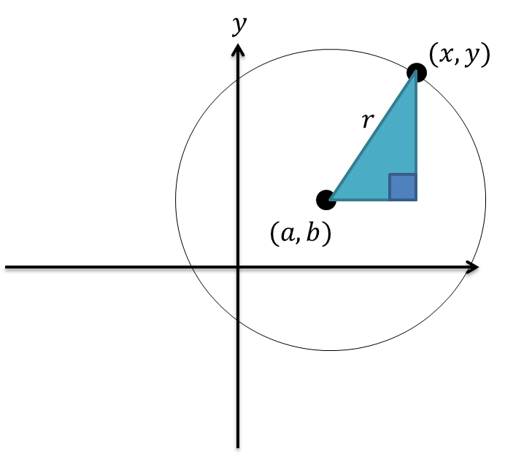
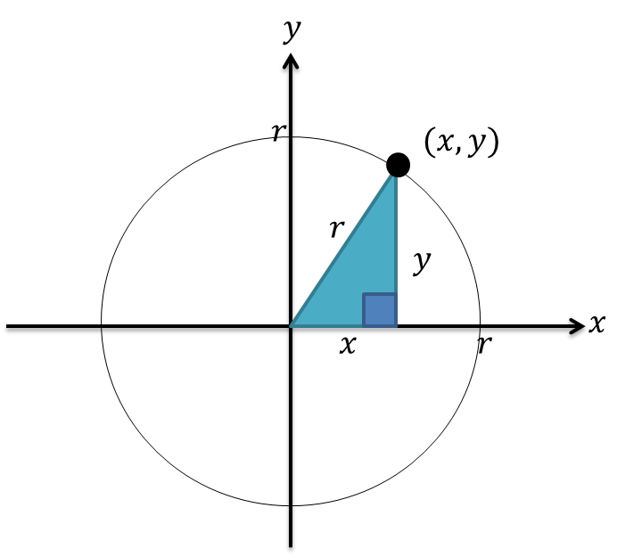

Examples:
1.
Centre | Radius | Equation
$$(0,0)$$ | $$5$$
$$(1,2)$$ | $$6$$
 |  | $${\left(x+3\right)}^{2}+{\left(y-5\right)}^{2}=1$$
 |  | $${\left(x+5\right)}^{2}+{\left(y-2\right)}^{2}=49$$
 |  | $${\left(x+6\right)}^{2}+y^{2}=16$$
 |  | $${\left(x-1\right)}^{2}+{\left(y+1\right)}^{2}=3$$
 |  | $${\left(x+2\right)}^{2}+{\left(y-3\right)}^{2}=8$$

2. A line segment $AB$ is the diameter of a circle, where $A$ and $B$ have coordinates $\left(5,8\right)$ and $\left(-7,4\right)$ respectively. Determine the equation of the circle.

Test your understanding
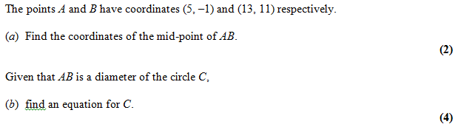

Completing the Square

Example
Find the centre and radius of the circle with equation $x^{2}+y^{2}-6x+2y-6=0$

Test your understanding
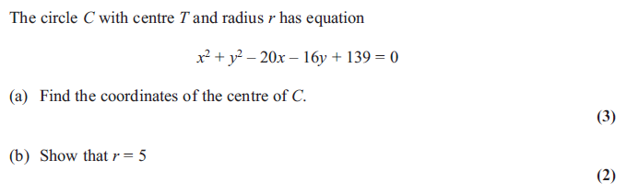

Extension:
1. [MAT 2009 1B] The point on the circle $x^{2}+y^{2}+6x+8y=75$ which is closest to the origin, is at what distance from the origin?

2. [MAT 2007 1D]
The point on the circle ${\left(x-5\right)}^{2}+{\left(y-4\right)}^{2}=4$ which is closest to the circle
${\left(x-1\right)}^{2}+{\left(y-1\right)}^{2}=1$ has what coordinates?

3. [MAT 2016 1I] Let $a$ and $b$ be positive real numbers. If $x^{2}+y^{2}≤1$ then the largest that $ax+by$ can equal is what?
Give your expression in terms of $a$ and $b$.

Exercise 6C Page 119 - 120

