Modelling with Linear Graphs
Many real life variables have a ‘linear’ relationship, i.e. there is a fixed increase/decrease in one variable each time the other variable goes up by 1 unit.

Example
The temperature $y$ at different points on a mountain is recorded at different altitudes $x$.
Suppose we were to use a linear model $y=mx+c$.

a) Determine $m$ and $c$ (you can assume the line goes through $\left(0,70\right)$ and $\left(250,20\right)$.

b) Interpret the meaning of m and c in this context

c) Predict at what altitude the temperature reaches $0°F$

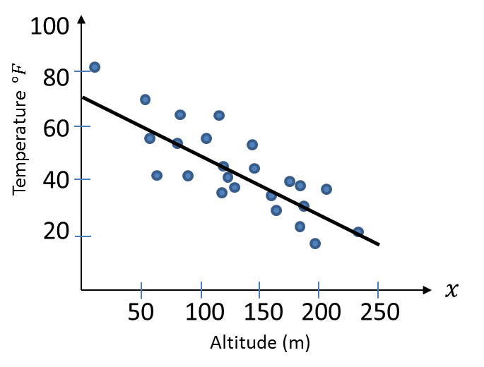

Evaluating a Model

Example:
The current population of Bickerstonia is 26000. This year (2017) the population increased by 150. Matt decides to model the population $P$ based on the years $t$ after 2017 by the linear model:
$$P=mt+c$$
Why might this not be a suitable model?
Exercise 5H Page 106/108

