Distances between points

Examples
Find the distance between

$(3,4)$ and $\left(5,7\right)$

$(5,1)$ and $\left(6,-3\right)$

$(0,-2)$ and $\left(-1,3\right)$

Test Your Understanding
Find the distance between:

$(1,10)$ and $\left(4,14\right)$

$(3,-1)$ and $\left(0,1\right)$

$(-4,-2)$ and $\left(-12,4\right)$

Area of Shapes
$$x$$
$$y$$
$$x+2y=4$$
$$y=3x$$
$$P$$
$$Q$$
$$O$$

Example 1
The diagram shows two lines with equations $y=3x$
and $x+2y=4$, which intersect at the point $P$.
a)Determine the coordinates of $P$.

b) The line $x+2y=4$ intersects the $x$-axis at the point $Q$. Determine the area of the triangle $OPQ$.
When $y=0, x=4$

$$x$$
$$2y=x+4$$
$$x+y=8$$
$$P$$
$$O$$
$$Q$$
$$R$$
Example 2
a)Determine the length of $PQ$

b) Determine the area $PQR$.

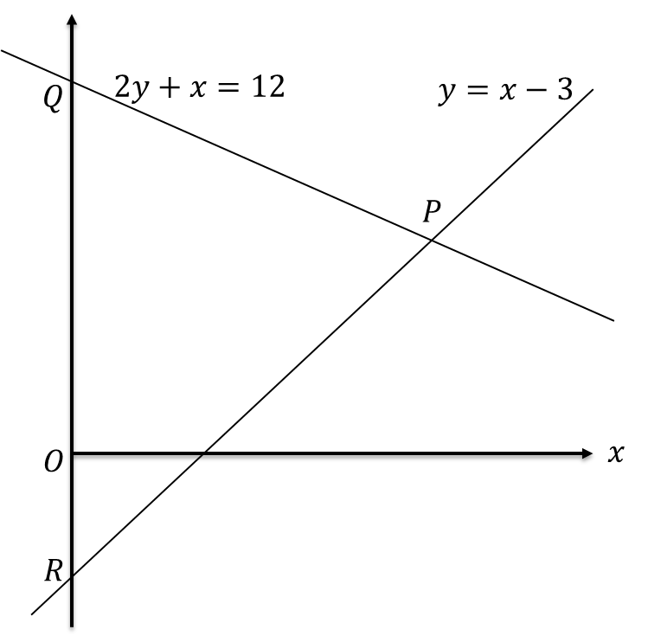
Test Your Understanding:

a) Determine the coordinate of $P$.

b) Determine the area of $PQR$.

c) Determine the length $PQ$.

Extension
[MAT 2001 1C]
The shortest distance from the origin to the line $3x+4y=25$ is what?

Exercise 5G Page 102/103

