Intersection of Lines:

Example
The diagram shows two lines with equations $y=3x$ and $x+2y=4$, which intersect at the point $P$.
a. Determine the coordinates of $P$.
b. The line $x+2y=4$ intersects the $x$-axis at the point $Q$. Determine the coordinate of $Q$.
$$x$$
$$y$$
$$x+2y=4$$
$$y=3x$$
$$P$$
$$Q$$
$$O$$

Test Your Understanding
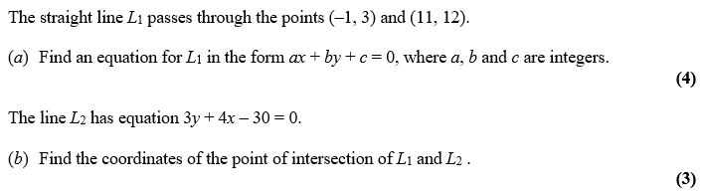

Exercise 5D Page 95

