Points of Intersection
If $y=f(x)$ and $y=g(x)$, then the $x$ values of the points of intersection can be found when $f\left(x\right)=g(x)$.

Examples:
1. On the same diagram sketch the curves with equations $y=x(x-3)$ and $y=x^{2}\left(1-x\right)$. Find the coordinates of their points of intersection.

2. On the same diagram sketch the curves with equations $y=x^{2}\left(3x-a\right)$ and $y=\frac{b}{x}$, where $a,b$ are positive constants. State, giving a reason, the number of real solutions to the equation $x^{2}\left(3x-a\right)-\frac{b}{x}=0$

Test Your Understanding
On the same diagram sketch the curves with equations $y=x(x-4)$ and $y=x{\left(x-2\right)}^{2}$, and hence find the coordinates of any points of intersection.

Extension
1. [MAT 2005 1B]
The equation ${\left(x^{2}+1\right)}^{10}=2x-x^{2}-2$
- has $x=2$ as a solution;
- has no real solutions;
- has an odd number of real solutions;
- has twenty real solutions.

2. [MAT 2010 1A] The values of $k$ for which the line $y=kx$ intersects the parabola $y={\left(x-1\right)}^{2}$ are precisely
- $k≤0$ B) $k≥-4$
C) $k≥0$ or $k≤-4$ D) $-4≤k≤0$

3. [MAT 2013 1D]
Which of the following sketches is a graph of $x^{4}-y^{2}=2y+1$?
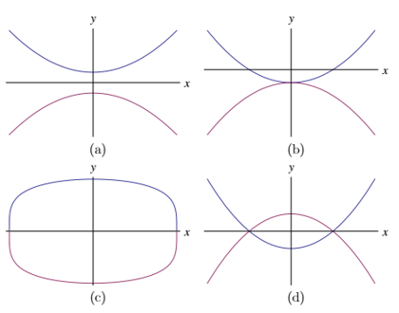

Exercise 4D Page 69

