2. Shade the region that satisfies the inequalities:
$$2y+x<14$$
$$y≥x^{2}-3x-4$$

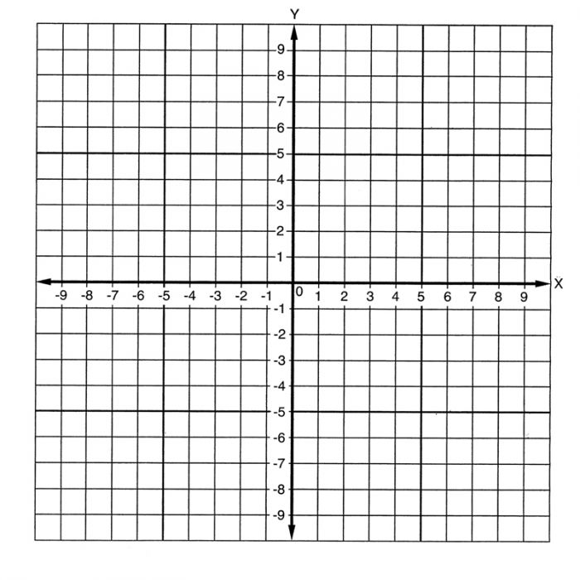

Exercise 3F/ 3G Page 53 – 55
45

