Quadratic Inequalities:

Example

Examples
1. Solve $x^{2}+2x-15>0$

2. Solve $x^{2}+2x-15≤0$

3. Solve $x^{2}+5x≥-4$

4. Solve $x^{2}<9$

Test Your Understanding

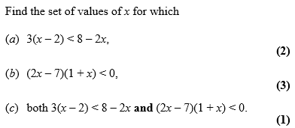

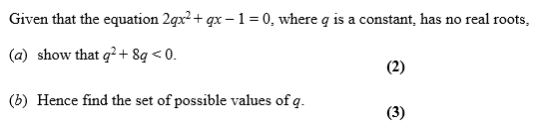

Division by x

Find the set of values for which $\frac{6}{x}>2, x≠0$

Exercise 3D/ 3E Page 47 – 51
45

