The Discriminant

Quickfire questions:
Equation | Discriminant | No. of distinct real roots
$$x^{2}+3x+4=0$$
$$x^{2}-4x+1=0$$
$$x^{2}-4x+4=0$$
$$2x^{2}-6x-3=0$$
$$x-4-3x^{2}=0$$
$$1-x^{2}=0$$

Example:
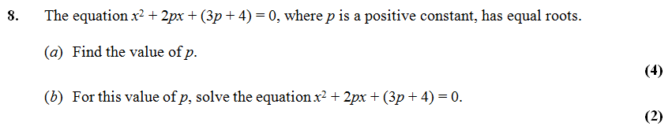

Test Your Understanding:
1. $x^{2}+5kx+\left(10k+5\right)=0$ where $k$ is a positive constant.
Given that this equation has equal roots, determine the value of $k$.

2. Find the range of values of $k$ for which $x^{2}+6x+k=0$ has two distinct real solutions.

Extension:
1.
[MAT 2009 1C] Given a real constant $c$, the equation $x^{4}={\left(x-c\right)}^{2}$ has four real solutions (including possible repeated roots) for:
- $c≤\frac{1}{4}$
- $-\frac{1}{4}≤c≤\frac{1}{4}$
- $c≤-\frac{1}{4}$
- all values of $c$

[MAT 2006 1B] The equation ${\left(2+x-x^{2}\right)}^{2}=16$ has how many real root(s)?
2.

[MAT 2011 1B] A rectangle has perimeter $P$ and area $A$. The values $P$ and $A$ must satisfy:
- $P^{3}>A$
- $A^{2}>2P+1$
- $P^{2}≥16A$
- $PA>A+P$
3.
Exercise 2G Page 32

