Chapter 2

Quadratics

Chapter Overview

1. Solving Quadratic Equations

2. Quadratic Functions

3. Quadratic Graphs

4. The Discriminant

5. Modelling with Quadratics



Solving Quadratic Equations

Examples

1. 2.

3. Solve 4.

Test your understanding

1. 2.

3. 4.

Extension

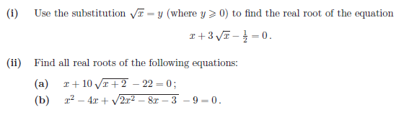

Exercise 2A/ 2B Page 20/ 22