Brackets: Expanding
Example: $\left(x+1\right)\left(x+2\right)\left(x+3\right)$

Questions
1. Expand and simplify
$$\left(x+5\right)\left(x-2\right)\left(x+1\right)$$

2. Expand and simplify:
$$2\left(x-3\right)\left(x-4\right)$$

3. Expand and simplify:
$${\left(2x-1\right)}^{3}$$

Extension
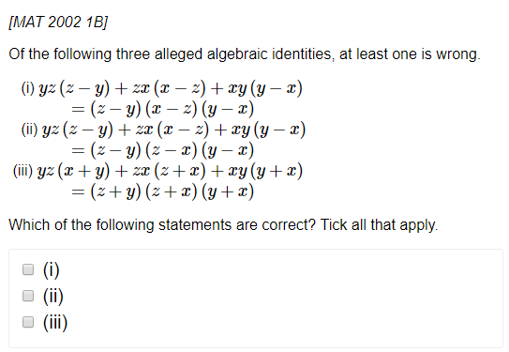
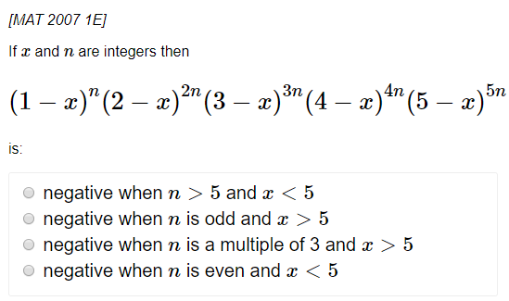
Exercise 1B Page 5-6

