A Level Mathematics

Chapter 1

Algebraic Expressions

Chapter Overview

1. Basic Index Laws

2. Negative/ Fractional Indices

3. Factorise Quadratics and Cubics

4. Expanding Brackets

5. Surds



Basic Index Laws

Examples

1. Simplify

2. Simplify

3. Simplify

4. Simplify $\frac{x^{3}-2x}{3x^{2}}$ ( 2 methods)

Test Your Understanding:

1. Simplify ${\left(\frac{2a^{5}}{a^{2}}\right)}^{2}×3a$ 2. Simplify $\frac{2x+x^{5}}{4x^{3}}$

3.Expand and simplify $2x\left(3-x^{2}\right)-4x^{3}\left(3-x\right)$

4.Simplify $2^{x}×3^{x}$

Extension

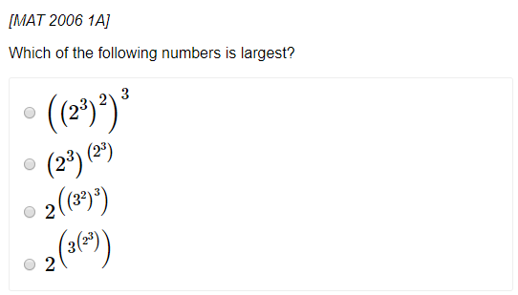

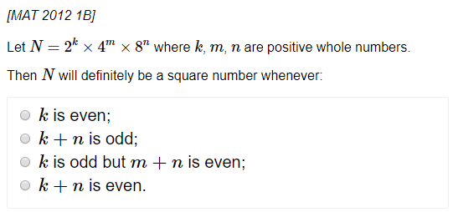

Exercise 1A Page 3