Optimisation Problems
We can use differentiation to solve optimisation problems because it allows us to find maximum and minimum values of functions.

Optimisation problems in an exam usually follow the following pattern:
- There are 2 variables involved (you may have to introduce one yourself), typically lengths.
- There are expressions for two different physical quantities:
  - One is a constraint, e.g. “the surface area is 20cm²”.
  - The other we wish to maximise/minimise, e.g. “we wish to maximise the volume”.
- We use the constraint to eliminate one of the variables in the latter equation, so that it is then just in terms of one variable, and we can then use differentiation to find the turning point.

Example
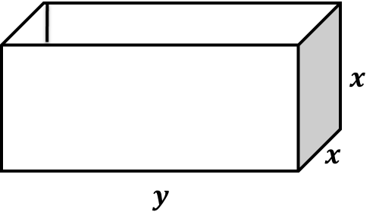
A large tank in the shape of a cuboid is to be made from 54m² of sheet metal. The tank has a horizontal base and no top. The height of the tank is $x$ metres. Two of the opposite vertical faces are squares.
a) Show that the volume, V m³, of the tank is given by
$V=18x-\frac{2}{3}x^{3}$.
b) Given that $x$ can vary, use differentiation to find the maximum or minimum value of $V$.

Test Your Understanding

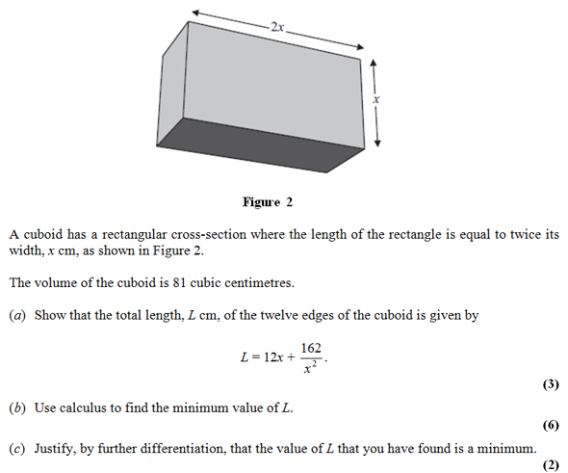

Extension
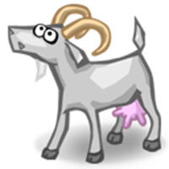
[STEP I 2006 Q2] A small goat is tethered by a rope to a point at ground level on a side of a square barn which stands in a large horizontal field of grass. The sides of the barn are of length $2a$ and the rope is of length $4a$. Let $A$ be the area of the grass that the goat can graze.
Prove that $A≤14πa^{2}$ and determine the minimum value of $A$.

Ex 12K page 281

