12J Graphing the Gradient Function
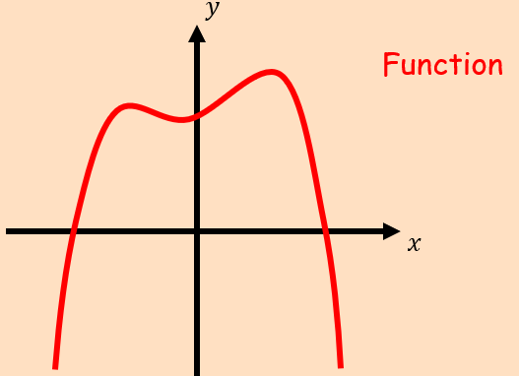
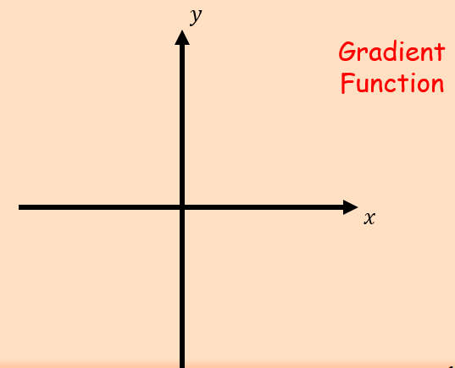
- The diagram shows the curve with equation $y=f(x)$. It has an asymptote at $y=-2$, a turning point at $(-3,-8)$and it cuts the x-axis at $(-10,0)$
- Sketch the graph of $y=f'(x)$
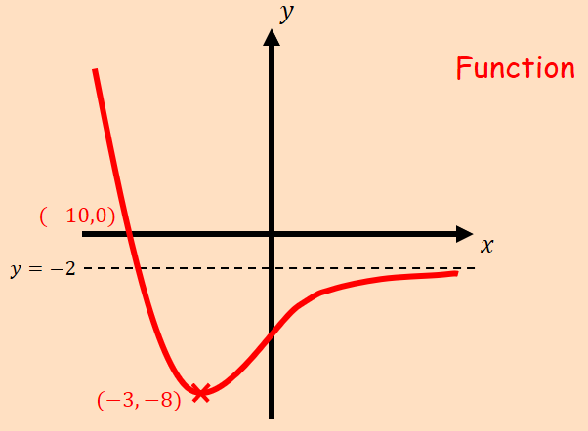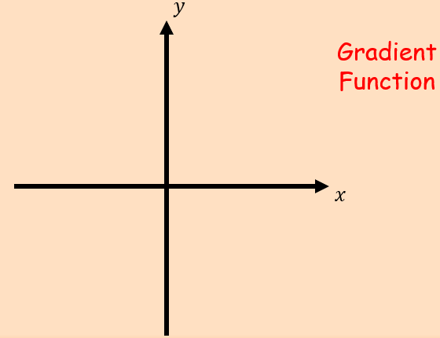

- State the equation of the asymptote of $y=f'(x)$

