Sketching Gradient Functions

Example
Sketch the gradient function for the function $f\left(x\right)=x^{2}+3x+2$

Sometimes you won’t be given the function explicitly, you will only be given the sketch.

Example

Example 2

Test Your Understanding

Summary
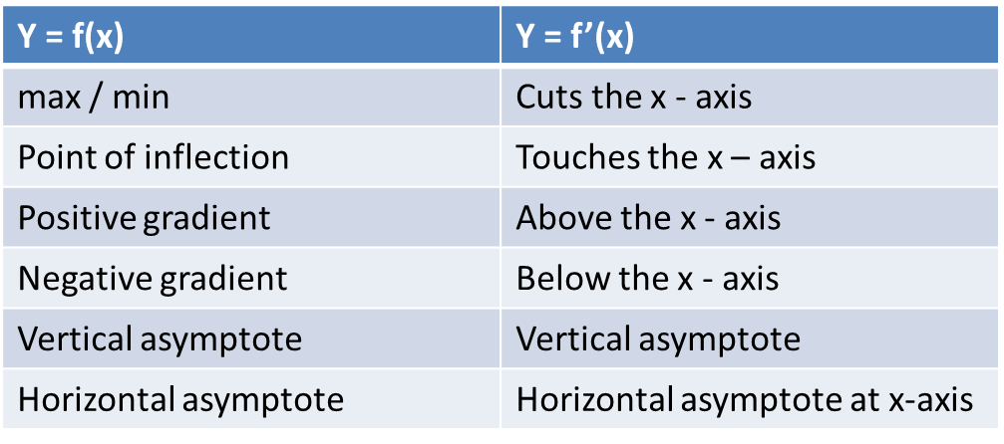

Extension
[MAT 2015 1B]
$$f\left(x\right)={\left(x+a\right)}^{n}$$
where $a$ is a real number and $n$ is a positive whole number, and $n≥2$. If $y=f(x)$ and $y=f'(x)$ are plotted on the same axes, the number of intersections between $f(x)$ and $f^{'}\left(x\right)$ will:
- always be odd
- always be even
- depend on $a$ but not $n$
- depend on $n$ but not $a$
- depend on both $a$ and $n$.

Ex 12J page 278

