12I Stationary Points
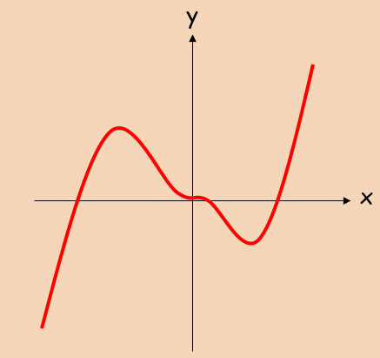
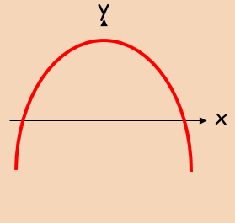
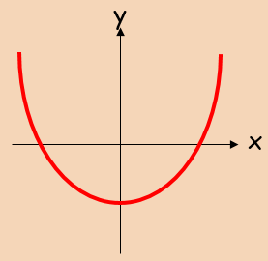

Note on f’’(x) = 0

- Find the coordinates of the turning point on the curve y = x⁴ – 32x, and state whether it is a minimum or maximum.

- Find the stationary points on the curve: y = 2x³ – 15x² + 24x + 6, and state whether they are minima, maxima or points of inflexion

