Stationary Points/ Turning Points

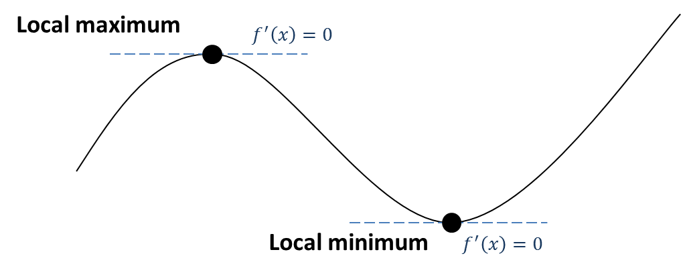

Examples
1. Find the coordinates of the turning points of $y=x^{3}+6x^{2}-135x$

2. Find the least value of $f\left(x\right)=x^{2}-4x+9$

3. Find the turning point of $y=\sqrt{x}-x$

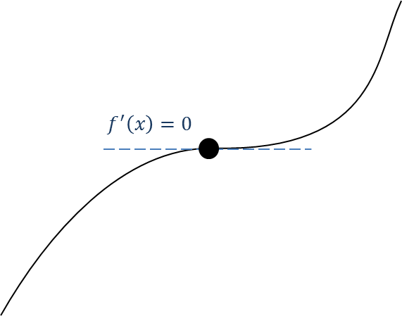
Points of Inflection

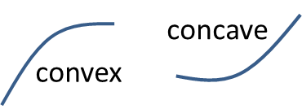

How do we tell what type of stationary point?
Method 1: Look at the gradient just before and just after the point

Local Maximum
Gradient just before | Gradient at maximum | Gradient just after

Local Minimum
Gradient just before | Gradient at minimum | Gradient just after
Point of Inflection
Gradient before | Gradient at p.o.i | Gradient just after

Example:
Find the stationary point on the curve with equation $y=x^{4}-32x$, and determine whether it is a local maximum, a local minimum or a point of inflection.

Method 2: Using the second derivative
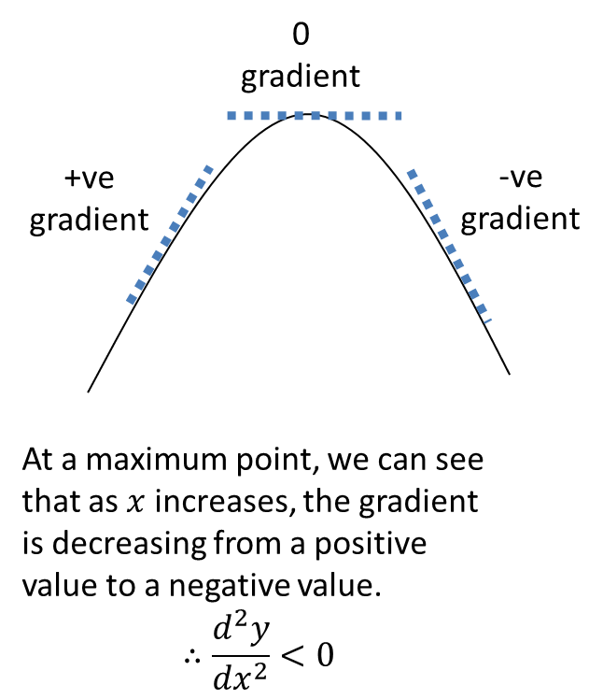

At a stationary point $x=a$:

- If $f^{''}\left(a\right)>0$ the point is a local minimum.
- If $f^{''}\left(a\right)<0$ the point is a local maximum.
- If $f^{''}\left(a\right)=0$ it could be any type of point, so resort to Method 1.

Example:
The stationary point of $y=x^{4}-32x$ is $\left(2,-48\right)$. Use the second derivative to classify this stationary point.

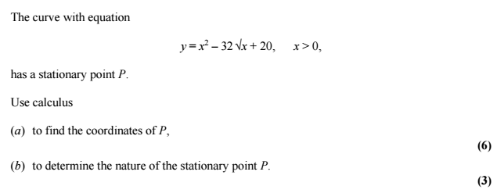
Test Your Understanding:

Sketching Graphs
We can sketch graphs to help classify stationary points.

Example
By first finding the stationary points, sketch the graph of $y=\frac{1}{x}+27x^{3}$

Extension
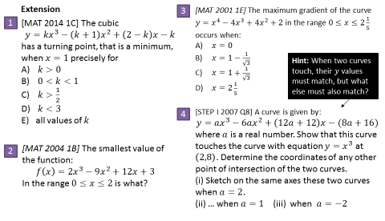

Ex 12I page 276

