12G Increasing & Decreasing Functions
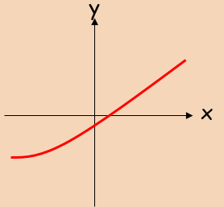
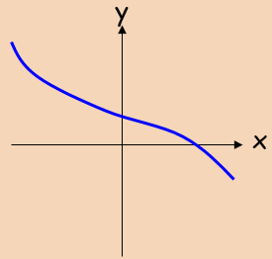
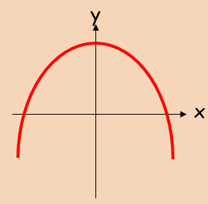
- Show that the function ;
$$f\left(x\right)=x^{3}+24x+3$$
is an increasing function.

- Find the range of values where:
$$f\left(x\right)=x^{3}+3x^{2}-9x$$
is a decreasing function.

