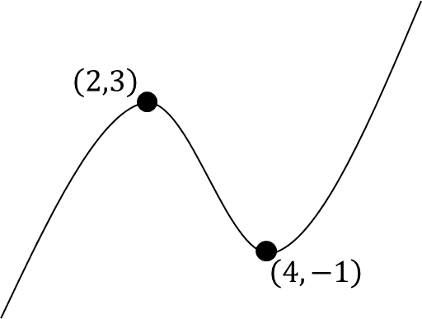
Increasing and Decreasing Functions

Examples
1. Show that the function
$f\left(x\right)=x^{3}+6x^{2}+21x+2$ is increasing for all real values of $x$.

2. Find the interval on which the function $f\left(x\right)=x^{3}+3x^{2}-9x$ is decreasing.

Test Your Understanding
1. Show that the function
$f\left(x\right)=x^{3}+16x-2$ is increasing for all real values of $x$.

2. Find the interval on which the function $f\left(x\right)=x^{3}+6x^{2}-135x$ is decreasing.

Ex 12G page271

