Quadratics in sin/cos/tan
Solve $5\sin^{2}{x}+3\sin{x}-2=0$ in the interval $0≤x≤360°$.

Solve $\tan^{2}{θ}=4$ in the interval $0≤x≤360°$.

Solve $2\cos^{2}{x}+9\sin{x}=3\sin^{2}{x}$ in the interval $-180°≤x≤180°$.

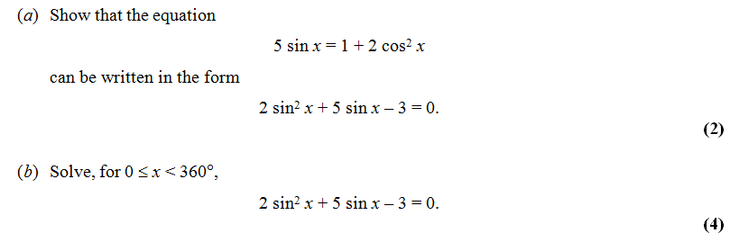

Exercise 10F Pg 221/222

AD Page 11
